MAJOR PERFORMANCE RESULTS
OF
BANK NATIONAL CLEARING CENTRE (JOINT-STOCK COMPANY)
FOR THE YEAR 2015

CONTENTS

1. General information. 3
2. Authorized capital and shareholder structure. 4
3. Industry position of Bank National Clearing Centre (Joint-Stock Company) 4
4. Development prospects 17
5. Devepoment results in major operational areas 22
5.1. Clearing in FX and precious metals market 22
5.2. Securities market clearing 24
5.3. Derivatives market clearing 25
5.4. Commodities market clearing 28
5.5. SFD market clearing 28
6. Proprietary operations in financial markets 29
7. Risk management, including measures aimed at maintaining high quality of management in NCC as CCP 32
8. Internal control system 51
9. Technological platform 54
10. Major financial performance results 56
11. Bank’s human resource management policy 59
12. Remuneration of CEO, members of the Executive Board and members of the Supervisory Board (criteria for calculation and amount of remuneration) 63
13. Stock dividends 64
14. Observance of the Corporate Governance Code 65

General information.
Bank National Clearing Centre (Joint-Stock Company) (hereinafter the "Bank", NCC) was founded in 2005 pursuant to the resolution of the General Meeting of Founders with the names “Joint-Stock Commercial Bank “National Clearing Centre” (Closed Joint-Stock Company)” and “CJSC JSCB National Clearing Centre”, and registered in the Interdistrict Federal Tax Service Office No. 50 for the City of Moscow on 30 May 2006 (Legal entity state registration certificate series 77 No. 010075586 dated 30 May 2006, Primary State Registration Number – 1067711004481).
On 30 May 2006, the Bank of Russia issued to the Bank the certificate of state registration of the credit institution No. 3466, and on 16 August 2006 – the license for banking operations in roubles and foreign currencies No. 3466 (without the right to raise private deposits).
In 2014, the Bank has been reorganized in form of affiliation to it of the Non-Banking Credit Organization “RTS Clearing House” (closed joint-stock company) and the closed joint-stock company RTS Clearing Centre. The Bank is a legal successor to the above legal entities, and it has assumed all of their rights and obligations, including the obligations disputed by the parties.
Pursuant to the resolution of the Bank’s sole shareholder, the Bank’s names were brought in conformity with the current legislation and now read as follows: Bank National Clearing Centre (Joint-Stock Company), and in short - NCC Bank (JSC).
Due to the performed change of the Bank’s name, on 17 March 2015, the Bank has renewed its license for banking operations in roubles and foreign currencies (without the right to raise private deposits) No. 3466, and the license for raising and placement of deposits in precious metals.
Pursuant to the Federal Law "On clearing and clearing activities" and in order to carry out clearing activities in accordance with the said Law, the Bank maintains the license for performance of clearing activities dated 18 December 2012.
The Bank also holds the license for development, production and distribution of encryption (cryptographic) means, information systems and telecommunication systems protected using encryption (cryptographic) means, performance of works and provision of services in the field of data encryption, technical maintenance of encryption (cryptographic) means, information systems and telecommunication systems protected using encryption (cryptographic) means (except where technical maintenance of encryption (cryptographic) means is conducted for own needs of the legal entity or private entrepreneur).
In 2015, the Bank was accredited by the Bank of Russia to perform functions of a commodity delivery operator.

Location
13 Bolshoy Kislovskiy per., Moscow
Mailing address
13 Bolshoy Kislovskiy per., Moscow, 125009

In the reporting period, the following internal structural subdivisions were operating:

- Sredniy Kislovskiy Additional Office of NCC Bank (JSC), located at: Bldg.8, 1/13 Sredniy Kislovskiy per., Moscow;
- Spartakovskiy Additional Office of NCC Bank (JSC), located at: Spartakovskaya ul. 12, Moscow.
On 28 May 2015, by resolution of the Board of the Bank, Vozdvizhenka Additional Office of NCC Bank (JSC), located at: Vozdvizhenka ul. 4/7 Bldg.1, Moscow, was closed.

Management bodies
According to the Articles, the Bank’s management bodies are as follows:
- General Shareholders Meeting is a supreme management body;
- Supervisory Board is a management body performing overall administration of the Bank's activities; members of the Supervisory Board are elected by the General shareholders meeting until the next annual General shareholders meeting;
- Executive Board (collective executive body) is a management body in charge of the current NCC's operations; members of the board are elected by the Supervisory Board; the term of each member of the Board in office is set by the Bank’s Supervisory Board but cannot exceed five years; and
- Chairperson of the Executive Board (hereinafter-CEO) (sole executive body) is a management body in charge of the current NCC's operations, elected by the Supervisory Board for the time period set by the Supervisory Board, but no more than five years.

The independent auditor of NCC for the year 2015 in accordance with the sole shareholder's resolution No. 25 dated 22 May 2015 is CJSC Ernst & Young Vneshaudit.

Authorized capital and shareholder structure.

When the Bank was established, the General meeting of founders approved the authorized capital of the Bank as 235,000,000 roubles, divided into 235,000 registered ordinary shares with par value of 1,000 roubles each.
During 2006-2013, the authorized capital of the Bank increased from 235,000,000 roubles to 15,170,000,000 roubles via allocation of additional registered uncertified ordinary shares of the Bank; and in 2014, due to the Bank’s reorganization in form of affiliation, the Bank’s authorized capital was increased through allocation of two additional issues of registered uncertified ordinary shares of the Bank in the total amount of 1,500,000 shares (not exceeding the number of declared shares) by converting into the latter the shares of the affiliated Non-Banking Credit Organization “RTS Clearing House” (closed joint-stock company) and closed joint-stock company RTS Clearing Centre.
As of the end of the reporting period, the authorized capital of the Bank equaled 16,670,000,000 roubles, divided into 16,670,000 registered uncertified ordinary shares with par value of 1,000 roubles each.

Shareholder structure
As of 31 December 2015, the register of shareholders of NCC Bank (JSC) contained one entry – Public Joint-Stock Company Moscow Exchange MICEX-RTS.
During the reporting period, the Bank’s Register of Shareholders was kept by the following Registrar: Closed Joint-Stock Company “Registrar Company STATUS”.

Industry position of Bank National Clearing Centre (Joint-Stock Company)
In 2015, the Bank’s operation was significantly influenced by external and internal factors.
As in 2014, the sanctions against clearing participants and the banks servicing the clearing participants potentially threatened financial stability and continuity of the Bank's critical services. In its operation, NCC had to take account of the threat to business continuity due to the risk of disconnection of its main communication channel – SWIFT - used to settle clearing obligations and to interact with correspondent banks in proprietary operations, as well as due to the risk of imposing sanctions against the Bank. NCC promptly responded to such threats when developing its strategy as regards management of the systemic component of operational risk, by achieving the objective of implementation of alternative communication channels.
During the reporting period, the quantity of credit institutions continued to decrease due to revocation of licenses by the Bank of Russia. In the environment where virtually all commercial banks, just as financial companies, were more or less engaged in operations in the organized (on-exchange) market, and, therefore, were NCC’s clients, in every license revocation case the Bank resorted to market stability maintenance measures using various elements of the risk management framework – from an ongoing financial monitoring of the clearing participants to default management procedures.
Owing to the active measures of the Bank of Russia in 2015, aimed at preventing capital outflow from the country, there were detected formally legal but essentially unlawful capital export schemes using securities market instruments. In this respect, NCC promptly took measures to adapt its financial monitoring and internal control system to the new environment. Owing to the coordination of this work with authorized subdivisions and services of the Bank of Russia, this process was successfully completed with no damage to non-defaulting securities market participants and with no disruption of normal functioning of this market.
Throughout 2015, the arising challenges and threats tested the strength of the risk management framework, including its parameters and default management procedures. Nevertheless, they did not become an obstacle for implementation of the projects jointly planned with Moscow Exchange Group.
In the reporting year, the Bank, going by the effective Group Strategy for the years 2012-2015, concentrated efforts on top priorities in implementation of the following projects and objectives:
- development of clearing services and processes;
- improvement of the risk management framework, primarily as regards the creation of a reliable protection of CCP and improvement of its management quality, complying with international standards; and
- meeting business revenue growth target.

As the results of joint efforts of Moscow Exchange Group and the regulator a favorable external environment was created for qualitative restructuring of the central counterparty risk management framework, enabling NCC to implement one of the top-priority projects of the year - to develop and implement a new CCP safeguard structure.
Since 01 November 2015, significant legislative amendments were made, which affected the Bank’s operating environment in part of systemic risk mitigation and enhancement of financial resources adequacy. The results of these changes are the following:
- The new regulatory environment was created to limit Bank’s responsibility when acting as a central counterparty That novelty is in compliance with the international standards regulating central counterparties’ activity, and has a significantly positive impact on the Bank's financial stability.
The implementation of these conditions is secured by the requirement to form a dedicated capital – a part of ССP’s equity (capital) , which, pursuant to the clearing rules, is intended to cover potential losses arising from Clearing members’ defaults and is used by CCP prior to the use of funds posted by non-defaulting members. Moreover, as one of the criteria of CCP management quality positive assessment the requirement is defined for CCP to have a mechanism of potential loss-sharing which allows to allocate the potential losses among clearing members in the event of insufficiency of CCP own funds available within the CCP safeguard structure (default waterfall).
- The transparency of adequacy criteria for the total sum of the financial resources was increased, which is intended for defense against different threats. Such transparency allows to create additional protection buffers to be used either in the event of clearing members’ defaults or when other negative factors arisen not directly associated with the default. These dedicated resources generation is reflected in the reporting of the Bank (since 01.11.2015 they include own equity of the credit organization), acting as CCP, for the purpose of covering of potential losses, triggered-off by clearing members not performing their obligations to CCP, and is used by the central counterparty prior to the use of guarantee funds (dedicated capital of CCP) posted by non-defaulting clearing members; assurance of termination or restructuring of the CCP’s activity; coverage of potential losses as the result of the CCP financial downturn caused by revenue reduction or increase of expenditures, which is irrelevant to the obligations non-performed by the clearing members.

- The regulatory pressure on statutory ratios was decreased by excluding from the calculation certain clearing assets (amounts on balance and off-balance accounts (in part), formed as a result of operations performance in course of the clearing activities and CCP functions execution. These exclusions do not include amounts on clearing and correspondent accounts of the Bank). The abovementioned exclusions correlate with the requirements of the dedicated capital formation, which, among the other measures of financial protection, realized within the mechanism of the waterfall of the Bank minimize the principal risks, related to the CCP functions the Bank performs in the course of its clearing activity. Similar changes affected the creation of provisions, which has the indirect influence on statutory ratios.
The changes in bank regulation of central counterparty activities have been reflected in the Bank's internal documents and implemented into business processes. On November 1, 2015 the Bank has implemented in the on-exchange markets a new, unified for all on-exchange markets of Moscow Exchange Group, central counterparty protection levels structure conforming to the requirements of the Bank of Russia (Ordinance 2919-U) and recommendations of international regulators (CPMI-IOSCO, ISDA). Thus, the limitation of the CCP’s liability was introduced, contemplating that the losses arising from default of a clearing member will be written off at the expense of the central counterparty protection levels, enabling to preserve NCC's banking capital necessary to continue its activity.
In 2015 NCC began the implementation of the strategic objective to adjust local practices of interaction in financial markets in compliance with the international standards in key aspects. Due to the fact that the Bank’s qualification as a CCP by a third country would enable NCC to provide clearing services to companies incorporated in the European Union, in 2015, an extensive work was started to adjust the Bank's internal documents in compliance with the requirements of the Regulation 648/2012 (legislative instrument of the European Union, EMIR). The Bank also entered into cooperation with the Bank of Russia on the issues of harmonization of the Russian legislation with the European regulation. In the first half of 2015, the Bank of Russia submitted to ESMA (EU securities market regulator) the application for recognition of the Russian Federation jurisdiction as the one meeting the requirements of the Regulation 648/2012. On December 2, 2015 NCC submitted to ESMA the application to be qualified as a CCP in accordance with the EMIR requirements. In 2016, it is planned to continue interaction with ESMA on the matters of obtaining the CCP status complied with the requirements of the Regulation 648/2012.
In the reporting year, efforts were made to maintaining NCC’s solid status of a qualifying central counterparty and a systemically important financial market infrastructure institute securing the Bank's unique position in a competitive environment and characterizing it as a highly reliable, financially stable, hi-tech financial market infrastructure institute. In July 2015, the Bank conducted a self-assessment of its activities in terms of their compliance with the Bank of Russia’s requirements as to the CCP’s risk management quality and reported to the regulator about the same. Following the principle of transparency of its operation, the Bank has beforehand ensured disclosure from 01 January 2016 of the information in accordance with additional requirements of the Russian regulator based on international standards CPMI-IOSCO (Committee on Payments and Market Infrastructures and Board of the International Organization of Securities Commissions).

In 2015, NCC actively participated in activity of the Russian and international professional associations and SROs (Association “Russia”, NFA, RSPP, EACH and CCP12), for the purpose of using them as sites for exchange of opinions on the most important issues related to regulation of financial market infrastructures and promoting its position on the issues of improving legislation and regulatory requirements; keeping dialogue with representatives of the leading European and global central counterparties on the issues of international standards for operation of infrastructural organizations.
In the reporting year, Fitch Ratings confirmed the Bank’s long-term local currency (LC) issuer default rating (IDR) at 'BBB' and viability rating (VR) at 'bbb' - one notch above the Russian sovereign rating - “BBB-“. The NCC long-term issuer default rating in foreign currency and rating forecast confirmed at the same level as the Russian sovereign rating - “BBB-“, “outlook negative”. The assignment of NCC ratings by an international rating agency is an additional source confirming the Bank’s financial stability. The rating obtained from Fitch Ratings is largely intended for foreign partners and for the counterparties-banks, for whom the presence of such rating, due to the prevailing banking practice and banking regulation, is important in relations with NCC, including in terms of setting limits to the Bank.
The Bank finished the year 2015 with a record profit and unprecedented increase in equity and key performance indicators. The considerable growth of NCC’s capitalization further strengthened the position of the Bank as one of the most highly capitalized central counterparties in the world. According to the data as of 01 January 2016 in the reporting form 0409123 “Calculation of equity (capital) (Basle III), NCC’s equity in the reporting period increased from 38.54 bn roubles to 54.13 bn roubles, i.e. by 40.5%. The growth of the Bank’s capitalization is an additional factor of the Bank's financial stability and its ability to withstand the persisting external threats and market stresses.
In 2015, the Bank continued to conduct clearing operations in all markets of Moscow Exchange Group (FX market and precious metals market, securities and money markets, derivatives market and SFD market) and in the commodity derivatives market and commodity spot market of JSC Moscow Energy Exchange. In December 2015, Moscow Exchange Group launched another on-exchange market – a commodity market of JSC National Commodity Exchange (grain market), also cleared by NCC.
The general scheme of NCC’s clearing operations in the on-exchange markets before the of 2015 was as follows:

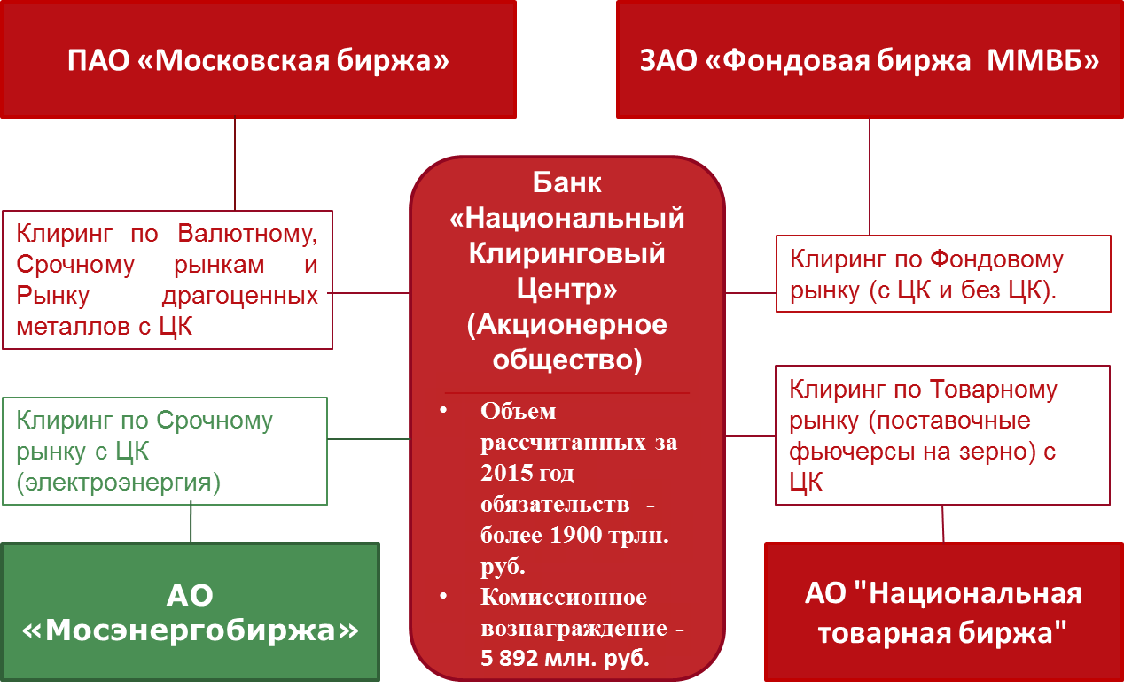
CCP clearing in the FX, Derivatives and Precious Metals markets
Bank National Clearing Centre (Joint-Stock Company)
- Volume of obligations for 2015 – over 1,900 trln roubles
- Commission fees – 5,892 mln roubles
JSC National Commodity Exchange
CCP clearing in the Commodities market (deliverable futures on grain)
Securities market clearing (with and without CCP)
JSC Moscow Energy Exchange
CCP clearing in the Derivatives market (electricity)
CJSC MICEX Securities Exchange
PJSC Moscow Exchange

Other most meaningful events of the last year include implementation of the following projects and objectives:

I. Grain Market Project
NCC implemented the functions of a clearing organization – central counterparty (in accordance with the terms of the trades) and commodity delivery operator (CDO) in the new segment of the on-exchange commodity market – the grain market, which was launched on 23 December 2015 at JSC National Commodity Exchange. To achieve this objective:
- NCC procured accreditation as an entity performing functions of a commodity delivery operator;
- the documents associated with performance of functions of a commodity delivery operator were developed and approved;
- the clearing rules for the commodities market were approved, registered by the Bank of Russia and made effective;
- the documents describing changes in software required for implementation of the project were developed and coordinated; and
- the software enabling organization of trading, performance of clearing and commodity delivery operator functions was developed and implemented.

Further, it is planned to launch instruments for other types of agricultural products, enabling to set prices for the products on the basis of an open and transparent on-exchange trade with central counterparty guarantees the settlement of all executed trades. Thus, implementation of the project has a strategic importance for the development of one of the most important export-oriented Russian industries – agriculture.

II. General Collateral REPO Project

The Bank completed a range of preparatory actions in anticipation of the year 2016 launch of the General Collateral REPO Project (herein after GCC-repo or REPO trades with GC Pooling), including:

- making legislative amendments necessary for the project launch, with direct involvement and expertise from NCC;
- development, approval and procurement of registration by the Bank of Russia of the version of the clearing rules containing the terms of the asset pool agreement and description of GCC-repo clearing specifics;
- development and coordination of the agreements on interaction with NCO CJSC NSD, containing the specifics of interaction in course of issuance and settlement of GC Pooling, and in course of using NCO CJSC NSD’s system of collateral selection for the purpose of picking up assets for asset pools;
- the documents describing changes in software required for implementation of the project were developed and coordinated; and
- the software required for implementation of the project was developed and scheduled for implementation.

The project contemplates the creation and use of fundamentally new instruments – GC Pooling certificates, which are non-issue certified securities subject to mandatory centralized custody. GC Pooling certificates are issued by the clearing organization (NCC) backed by assets posted by clearing members or its clients into certain asset pool. NCC decides on formation of an asset pool and delivers the global certificate for GC Pooling for centralized custody to NCO CJSC NSD.
The launch of this project, which is scheduled for the early 2016, will enable the following benefits of use of GC Pooling as a universal collateral:
- transmitting liquidity via REPO with GC Pooling at all levels of the financial system: from the Bank of Russia to non-bank organizations;
- ensuring preservation of property title to the assets posted into the pool: right to receive income and voting right;
- maximum efficient management of assets in collateral:
it is possible to carry out settlements of the trades using the assets posted into the pool.

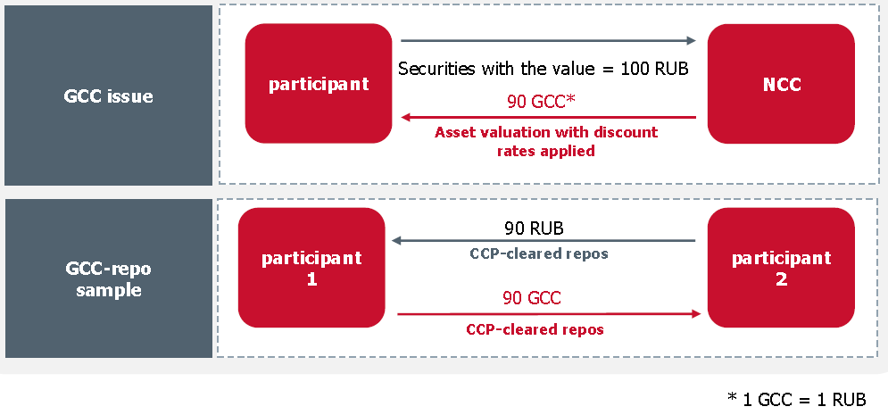
The specifics of GC Pooling can be illustrated by the following diagram:
III. Formation of unified clearing rules
- GC Pooling:
- is a new type of security
- is a result of securitization of collateral
- enables to obtain a uniform universal collateral for liquidity management by executing REPO trades
- NCC issues GCCs against assets deposited to the pool, or a participant may receive GCCs through repo trades
- Clearing members use GCC to repo trade with CCP

Since 03 August 2015, a new version of the clearing rules was enacted, common part of which is the same for the FX market and precious metals market, securities market and derivatives market. The unification of the clearing rules in a unified version containing the rules and procedures common for all of the said markets has enabled, inter alia, to achieve the objective of conducting a unified liquidation netting of obligations arising from the trades executed in all of the said markets.

IV. Unification of the procedure for recording of guarantee funds’ resources
The Bank performed unification of the procedure for recording of resources of the guarantee funds of the FX market and precious metals market, securities market, derivatives market, commodities market, and the range of assets accepted as collateral to guarantee funds, creating additional preconditions for more efficient and convenient use of own funds by the participants. As a result of the unification:
- the posting of resources to the guarantee funds of the securities market, derivatives market, commodities market, FX market and precious metals market is performed to a single account;
- for the purpose of recording the cash posted to guarantee funds, for each clearing participant in NCC's accounting a separate settlement code is provided to record the resources of guarantee funds;
- the recording of securities in guarantee funds is performed in depo sub-accounts of the clearing participants opened to NCC’s depo clearing account with NSD:
- only one depo sub-account is opened to each clearing participant;
- information about the opened depo sub-accounts is transferred from NSD to NCC;
- prior to the beginning and in course of trading, information about the quantity of securities recorded in depo sub-accounts is transmitted to the Trading and Clearing System of the securities market;
- crediting/writing off securities to/from the depo sub-account is performed solely upon instruction from NCC;
- it is possible to transfer securities between depo sub-account and trading section opened in the proprietary trading depo account of the clearing participant.
- guarantee funds of different on-exchange markets are not combined;
- the debt of a defaulting clearing participant arising in one of the on-exchange markets may be repaid out of contributions of the defaulting clearing participant to guarantee funds of all on-exchange markets and contributions of non-defaulting clearing participants in the on-exchange market where the said debt has arisen (and it cannot be repaid out of contributions of non-defaulting clearing participants to guarantee funds of other on-exchange markets).

As part of unification of the procedure for recording of guarantee funds’ resources, there has been established a single list of assets accepted to the guarantee funds, and there has been determined the procedure for assessment of assets posted to these funds, and measures applied against the clearing participant if the contributions are insufficient.

V. Implementation of the unified liquidation netting procedure

In 2015, a unified liquidation netting procedure was implemented for the FX market and precious metals market, securities, derivatives and commodities markets.
In course of liquidation netting, the clearing centre calculates the amount of net obligations / net claims of the clearing participant in Russian roubles under the central counterparty trades and for other obligations arising between the clearing participant and NCC, as well as for the resources provided by the clearing participant to NCC as individual, collective and other collateral. The implementation of this project has enabled additional increase in NCC’s reliability as a central counterparty.

VI. Implementation of the project contemplating the transfer of obligations and collateral from the clearing participant’s client to another clearing participant
The implementation of this project has enabled registration, upon application of the clearing participant, of segregated clients in the FX market and precious metals market, in the securities market and segregated brokerage firms in the derivatives market. Now a segregated client / authorized account owner may use the transfer of obligations/claims and collateral from its clearing participant in case of its default to another clearing participant in accordance with paragraph 4 of Article 22 of the Federal Law “On clearing and clearing activities”. At that, a segregated client may be the client of the clearing participant who may be the trading participant or the client of the clearing participant’s client. The transfer of obligations and collateral from the clearing participant’s client to another clearing participant is performed as follows:
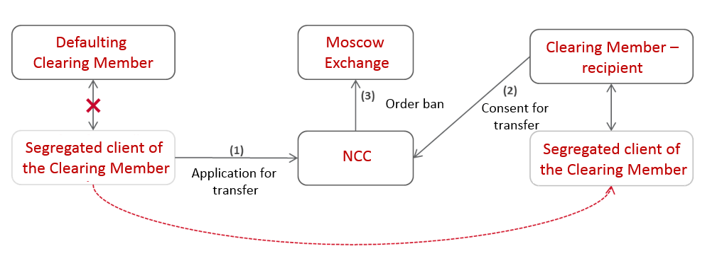

The introduced procedure for transfer of obligations and collateral underwent an expert assessment of the international adviser ( UK law firm Clifford Chance CIS Limited), which issued an opinion on principal conformity of the technology implemented in this project to the EMIR requirements.

VII Development and updating of methodological documents related to risk management and managing the Bank’s capital

For the purpose of ensuring conformity of NCC’s risk management system to the requirements of the Bank of Russia and international standards, and as part of improvement of internal capital adequacy assessment process (ICAAP), the following documents were developed and approved in 2015:
- Rules for organization of the Bank’s risk management system;
- The Bank’s risk management and capital management strategy;
- The Bank’s risk appetite indicator ratios for the year 2016.

The rules for organization of the risk management system contain general provisions determining the risk management system of the Bank as a clearing organization, credit organization, and commodity delivery operator. The document contains a description of the procedures for identification, monitoring and control of risks, the measures for mitigation of risks, and criteria for application of such measures.

The strategy of managing risks and capital is aimed at harmonizing of the process of managing risks associated with the Bank’s banking activities and its connection with capital adequacy management.

The Bank’s risk appetite indicator ratios for the year 2016 have been developed as part of implementation of the provisions of the Risks and Capital Management Strategy and set threshold values for quantitative and qualitative indicators of the level of significant risks for the forthcoming year.

The improvement of methodological base of the processes associated with managing risks and capital is an integral stage of the Bank’s development, and it will be continued in 2016.

VIII. Self-assessment of the Bank's activities for compliance with the CPMI-IOSCO principles for financial market infrastructures

As a result of performance of an annual self-assessment, a conclusion has been made that the Bank observes the majority of international principles and is a state-of-the-art central counterparty clearing organization using a reliable risk management system and providing high-quality services to the clearing participants and their clients in the same way as any other infrastructural organization in the world’s leading markets.

IX. A delimitation of the factors of legal and regulatory risks of the Bank’s operation has been implemented in the Bank’s internal documents and operating practices

For the purpose of bringing NCC's legal risk management system in compliance with the new requirements of the Bank of Russia, NCC, by resolution of its Supervisory Board, approved the new wording of the Regulation on organization of legal risk management in Bank National Clearing Centre (Joint-Stock Company). In order to establish a system for managing the regulatory risk of NCC, the Bank, by resolution of its Supervisory Board, approved the Regulation on organization of regulatory risk (compliance risk) management in NCC, and the internal documents – NCC’s Anti-Corruption Policy and NCC’s Procedure for avoidance of the conflict of interest.

X. Bringing the Bank's Articles into compliance with the new requirements of the Russian Civil Code and legislative changes in the Russian Federation
The work in this field was conducted for the purpose of complying with the new requirements of the Russian Civil Code and legislative changes in Russia, which are directly connected to the clearing activities and to the central counterparty function, to reforming by the Bank of Russia of the personnel remuneration system existing in credit organizations, and also touch upon the terms of implementation of the Grain Market Project of Moscow Exchange Group.
As a result, throughout 2015, amendments were made to the Bank’s Articles in connection with the following:
- change of the Bank’s trade name;
- vesting the Supervisory Board with the authority to elect the CEO;
- providing the Bank with the right to perform functions of a commodity delivery operator;
- possibility of using NCC’s “dedicated capital” and, if necessary, the additional dedicated capital of the Bank as CCP.

A reliable performance of its obligations to clearing participants and successful implementation of business projects related to development of client-oriented clearing services have enabled a considerable growth in volumes of the services provided to clearing participants.

As of 31 December 2015:
- total quantity of clearing participants is tantamount to 713 entities;
- in 2015, the volume of the clearing participants’ obligations determined upon conclusion of the clearing exceeded 1,989 trln roubles, which is 1.4 times higher than in 2014 (1,360 trln roubles);
- the size of commission fees received is tantamount to 5,893 mln roubles, which is 1.3 times higher than in 2014 (4,567 mln roubles).

The quantitative performance indicators of the Bank in major markets are reflected in the following diagrams:

Development prospects
In 2016, NCC’s main efforts will be directed towards implementation of the projects aimed at achieving the objectives set for the Bank in the Group Strategy for the years 2015-2020, approved by the Supervisory Board of PJSC Moscow Exchange, namely the improvement and unification of the risk management system in all markets, formation of a single clearing and settlement pool for all markets of the Moscow Exchange, formation of a unified collateral pool, introduction of the world’s best practices and compliance with international standards in clearing activities and in performance of central counterparty functions. Along with the foregoing, it is planned, while strictly adhering to the treasury policy approved by the Supervisory Board of NCC, to pursue the goal of achieving the profitability targets set by the Group for the Bank’s proprietary financial operations for the year 2016. The year 2016 plans also contemplate implementation of the range of measures associated with transformation of NCC’s status from the Bank to a non-bank credit organization – central counterparty, pursuant to the amendments to the Federal Law “On clearing, clearing activity, and central counterparty” adopted in 2015.
Forecasting continuance, and possibly even strengthening in 2016 of the negative external backdrop caused by the sanctions, also keeping in mind the high probability that the trend for sanation of the banking sector by the regulator will persist, the Bank will be paying utmost attention to monitoring the situation in the global and Russian financial markets, directly tracking the activities of the clearing members, partners and counterparties for the timely response to external and internal challenges, thus ensuring continuity of the critical services provided by NCC in the field of clearing and in performance of the central counterparty function.

The Bank’s development prospects in 2016 are linked to implementation of the Group’s important infrastructural business projects.

The following projects are planned for implementation in the clearing and risk management fields:

A. Unified Collateral Pool Project is the strategic vector for development of NCC's clearing activities

Main project goals
- decreasing the costs of funding operations in the derivatives market, FX market and precious metals market by using a wide range of assets recorded in the securities market accounts, and also through withdrawal of existing restrictions on acceptance of assets (share of assets) as individual clearing collateral;
- ensuring easiness and convenience of access to cross market operations via unification of the procedures for posting of individual clearing collateral and performance of obligations;
- cutting costs of operations in the infrastructure of Moscow Exchange Group through unification of clearing procedures.

Main project implementation objectives and directions
- using a unified trading and clearing account (set of accounts in all currencies, securities with the same identifier) for the individual clearing collateral in the securities, derivatives and FX markets;
- using the individual clearing collateral to ensure settlement and to settle obligations under the trades executed in different markets if the clearing member has not stated otherwise;
- choosing the quantity and types of trading and clearing accounts registered by clearing members with NCC in accordance with legislative requirements and needs of the clearing member;
- unifying the rules and procedures for acceptance of assets as individual clearing collateral in different markets (unification of the asset range, collateral rates and concentration limits, unification of the utilization procedure, including the same for the purpose of fulfillment of margin calls and repayment of debt);
- interproduct spreads for alpha-dependent positions – for positions in EUR and USD in the FX market, for positions in Russian sovereign bonds (OFZ) of various issues in the securities market, etc. (in calculation of the single limit, a discount will be set for the interproduct spread, which will reduce the required collateral for the positions included in the spread, as compared to the collateral requirements charged to such positions taken separately).
- introducing a unified procedure of variation margin settlements (the obligations of clearing members in variation margin calculated during clearing sessions held in the derivatives and FX markets shall be settled from the accounts of the unified collateral pool).
- withdrawal in the amount of the settlement position (cash withdrawals upon requests of clearing members from the accounts of the unified collateral pool shall be conducted with account of NCC’s obligations with matured settlements dates, recorded in these accounts, on an ongoing intraday basis, subject to the established cut-off time deadlines for the relevant currencies).

Procedure for recording of resources in the unified collateral pool
The following will be used as the accounts of the unified collateral pool:
- clearing bank accounts of the securities market;
- trading depo accounts of the securities market;
- trading and clearing accounts of the securities market.
The range of assets accepted into the Unified Collateral Pool will include:
- roubles;
- foreign currency;
- securities.
The foreign currencies and securities accepted as individual clearing collateral will be selected and evaluated using a single methodology based on the existing securities market methodology.
The information about the collateral recorded in the unified collateral pool will be transmitted to the derivatives market, FX market and precious metals market by means of transferring to the trading and clearing systems of the derivatives market, FX market and precious metals market of a portion of the single limit or the profile of positions in assets recorded in the accounts of the unified collateral pool.
The accounts of the unified collateral pool will be used solely upon request of a clearing member, i.e. the possibility of using different (separate) accounts for posting the collateral for different markets will be preserved.

The procedure for transfer of information about collateral among different markets is determined in accordance with the following diagram
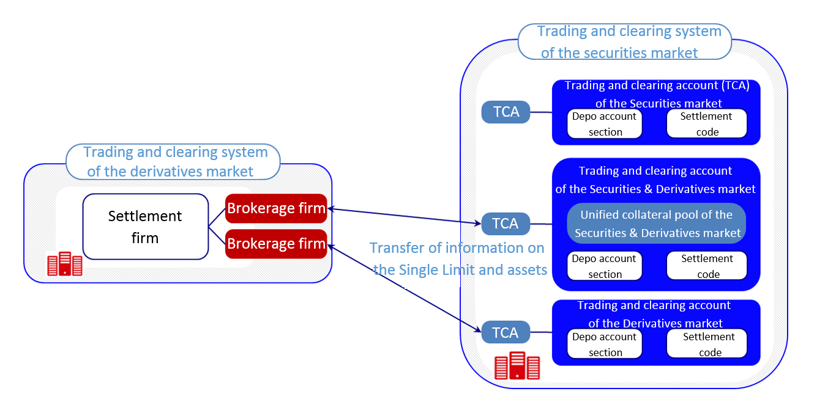

Specifics of implementation of the unified collateral pool in different markets
In the derivatives market
- the Bank will abandon the FORTS sections used at present for crediting to the derivatives market of the individual clearing collateral in securities, and will shift to using for these purposes the 36 sections of the depo accounts of the securities market;
- the obligations on payment of variation margin under the trades executed in the derivatives market will be settled in the accounts of the unified collateral pool;
- there will be no significant changes in the technology of collateral volume calculation in the derivatives market. The Bank will use a pre-order-validation procedure. The single limit transferred to SPECTRA will be accounted in calculation as roubles, and the transferred asset profiles will be accounted as “pledges” or as assets (after implementation – in calculation of the collateral for the derivatives market for “covered sales”);
- the technology of delivery under the derivatives contracts used in the derivatives market will be improved (the collateral for delivery will be blocked in one spot - in the Unified Collateral Pool, and not in two trading and clearing systems as is presently the case).
In the FX market and precious metals market
- the obligations on payment of variation margin and obligations under the trades with matured settlement dates will be settled in the accounts of the unified collateral pool;
- there will be no changes in the technology of calculation of the single limit in the FX market. The Bank will use a pre-order-validation procedure. The single limit transferred to the trading and clearing system of the FX market will be accounted in calculation as roubles, and the transferred asset profiles will be accounted as currency or as precious metal.

B. Development of the FX market and precious metals market
Main development vectors
  - further development of the project “Separation of statuses of trading participants and clearing members in the FX market and precious metals market” for the purpose of developing of the services related to tracking obligations and collateral in trading and clearing accounts and settlement codes of the 2nd and 3rd levels;
  - supplementing of NCC’s clearing rules with one more model for separation of statuses of the trading participants and clearing members - enabling a trading participant to execute trades on behalf of a clearing member, which is necessary for enabling the clearing member to become a party to the trade in its own interests, unlike the clearing broker model;
  - launch of new instruments – deliverable currency futures; at the first stage it is planned to launch a futures contract for delivery of US dollars for Russian roubles, a futures contract for delivery of euro for Russian roubles, and a futures contract for delivery of Chinese yuans for Russian roubles.

C. The project to create clearing terminals for clearing members

Project purpose
- formation of a unified system for receiving and processing of incoming requests of clearing members.
The clearing terminal of the clearing member will be implemented in the form of a web- supplement enabling the clearing member:
- to monitor information about its proprietary positions, client positions, cash and collateral, consolidated across all markets of the Moscow Exchange;
- remotely, safely and on an authorized basis, to submit electronic requests to NCC, perform non-trading transactions, control their settlement and obtain legally significant responses from the exchange.
On NCC’s side, the application from the clearing member will be automatically decoded and further processed depending on the type of application. In the clearing terminal, the clearing member will be able to access consolidated information for all issued applications, applications under processing, and processed applications.
D. Development of the commodities market

Major projects

- launch in the commodities market of CJSC NCE of a new financial derivative – a swap contract with the following specifics:
- the date of settlement of obligations under the first part of the swap contract is the day of conclusion of the swap contract;
- the date of settlement of obligations under the second part of the swap contract is from 3 to 90 calendar days after the date of settlement of obligations under the first part of the swap contract;
- the first part of the swap contract is cleared with full prefunding in cash and commodities, and the second part of the swap contract is cleared with partial prefunding in cash and commodities.
- participation of NCC as central counterparty in settlement of obligations under grain trades. Such possibility has emerged due to adoption in 2015 of the Federal Law No. 326-FZ “On adoption of amendments to the second part of the Tax Code of the Russian Federation”, pursuant to which, on 01 January 2016, there will become effective the amendments to the Tax Code related to the neutral VAT status for the central counterparty and commodity delivery operator in the commodities market.

E. Risk management objectives

The major efforts will be concentrated on pursuing the tasks of modernization and further development of key risk management components of the central counterparty activity in the following fields:

  - development of a new cross margining model and technology for the on-exchange markets of the Moscow Exchange;

  - improvement of stress testing approaches and methods (new uniform scenarios for various CCP safeguard structure (waterfall);

  - maintaining compliance of NCC’s risk management system with the requirements of the Bank of Russia for a qualifying central counterparty and the standards of the international regulator CPMI-IOSCO;

  - improvement of methodological base of the processes associated with managing risks and capital;

  - monitoring of advanced practices and technologies using the possibility of NCC’s participation in the work of the EACH Risks Committee, for the purpose of implementing those of them which correspond to the objectives of implementation of the Group Strategy for the years 2015 to 2020;

  - support of the process of examination by ESMA of the issue to grant to NCC the status of qualifying CCP in accordance with the EMIR requirements.

II. NCC’s objectives in development and optimization of proprietary operations

In 2016, for NCC as a central counterparty, the following areas of activity will still be important in performance of financial operations:
- ensuring balanced asset structure when changing the liability base subject to the requirements to maintain high reliability of assets and securing their yield;
- optimizing the correspondent network to ensure timely performance of clearing settlements with acceptable ratio of credit risk and cost of service (profitability);
- development of the default management procedures, including the procedures used in organization of clearing of the financial instruments newly introduced in the Moscow Exchange.

In the environment of high volatility of financial markets, NCC’s liability base, mainly consisting of the cash posted by clearing participants to secure their participation in the trading, is also subject to considerable fluctuations. Combined with significant volume of collateral (particularly in foreign currency), this factor results in higher requirements to the level of immediate and short-term liquidity, thus necessitating the use of financial instruments with high liquidity, high credit quality and the possibility of refinancing. Therefore, in 2016, considerable efforts will be directed to increase the shares of state debt obligations and other assets with high credit rating in NCC’s portfolio. For the purpose of decreasing risk while maintaining an acceptable yield rate, it is planned (provided that market conditions are favorable) to actively use such instrument as the reverse REPO in foreign currency.
The year 2015 has seen final establishing the trend where foreign correspondent banks set an increasing number of restrictions on the use of correspondent accounts by NCC, due to further tightening of compliance control procedures and changes in local regulatory requirements to correspondent banks. In this environment, the following objectives will be important in the area of optimization of the correspondent network in 2016:
- decreasing concentration of cash in correspondent accounts by acquiring highly reliable and highly liquid assets in foreign currency. To this end, it is planned to start operations with the US government bonds and secure considerable growth of portfolio of Eurobonds of highly reliable issuers;
- forming a portfolio of balances on correspondent accounts in foreign currency, ensuring, on the one hand, satisfaction of the restrictions set by correspondent banks in relation to the permitted maximum level of balances, and on the other hand – an acceptable interest income (expenditure) on correspondent account balances;
- determining correspondent accounts optimal for settlements in terms of the payment routing, minimization of time spent on settlements, etc. Preference will be given to correspondent accounts in the banks where the relevant correspondent accounts of clearing members are opened.

With regard to the default management, in 2016, it is planned to organize managing the default positions of clearing members in new financial instruments of the Moscow Exchange. Given that in 2016 the Bank starts conducting REPO operations with GC Pooling, special attention will be paid to operations in case of defaults in GC Pooling trades. The settlement of defaults under GC Pooling trades will retain the basic principles used in respect of the standardized financial instruments traded in the Moscow Exchange, whose underlying assets are securities or currencies. At that, the managing of defaults in GC Pooling trades will require introduction of a number of additional procedures, in particular, the procedures for management of assets of the clearing members, which are pledged in GC Pooling trades.

Specifics of clearing activities in different markets

5.1. Clearing of the FX market and precious metals market

The FX market of the Moscow Exchange is the Russia’s oldest organized on-exchange market, where foreign currency has been traded since 1992, and since 2013 there has been developing the trading and clearing of operations in precious metals. The on-exchange FX market is the centre of liquidity in cash operations and the most important segment of the national financial system. The Bank of Russia uses the on-exchange FX market to implement its monetary policy and determines official rates of US dollar and other foreign currencies against rouble, using the results of the on-exchange trading. The fixing at the Moscow Exchange also serves as a basis for calculation of the settlement price of futures contracts on foreign currency exchange rate.
Today, the FX market and precious metals market of the Moscow Exchange is a state-of-the-art on-exchange market meeting all necessary regulatory requirements and latest technological standards, hosting organized trading in major global currencies and accounting for the major volume of foreign exchange transactions. The convenience and unique nature of the on-exchange FX market are based on the uniform trading and post-trading infrastructure of the Moscow Exchange Group, providing its clients a full range of trading, clearing, settlement and information services. Trades are executed in accordance with the rules of organized trading of PJSC Moscow Exchange in the FX market and precious metals market in the double counter-auction mode. Trades are executed automatically, progressively as counter-orders with mutually satisfactory prices are entered into the system. Also, there exists a separate mode for execution of off-the-book trades. The functions of the trading organizer and technical centre are performed by PJSC Moscow Exchange, and the functions of the clearing organization and central counterparty are performed by NCC.
The Bank has been performing clearing in the FX market since 10 December 2007. The trades executed in this market are cleared and settled with participation of NCC as central counterparty. The Bank performs CCP functions for all executed trades, guaranteeing settlement of obligations to non-defaulting clearing participants, thus significantly decreasing the risks of clearing participants and relieving them from the need to set limits to each other. The FX market trading is conducted without full prefunding, using a highly efficient and reliable risk management system.
NCC conducts clearing in accordance with the clearing rules. The list of currencies traded in the FX market comprises US dollars (USD), euro (EUR), British pound (GBP), Hong Kong dollar (HKD), Chinese yuan (CNY), Ukrainian hryvnia (UAH), Kazakh tenge (KZT) and Belarusian rouble (BYR); also, swap trades with various maturities are executed. In respect of the currency pairs USD/RUB, EUR/RUB, CNY/RUB participants may execute long swap trades with the following maturities: 1W, 2W, 1M, 2M, 3M, 6M, 9M and 1Y. The major currency pairs are USD/RUB and EUR/RUB. There is an active development of the on-exchange yuan market, as well as operations in national currencies of the Eurasian Economic Union (EAEU). The trading time is 10:00 to 23:50 Moscow time.
In the FX market and precious metals market, NCC clears spot and swap trades, and since 2014 it has been also clearing financial derivatives (swaps and futures) traded with or without full prefunding. The collateral may be posted in cash (Russian roubles, US dollars, Euro, Chinese yuans, Hong Kong dollars and British pounds) and in precious metals (gold and silver).
In the FX market and precious metals market, trades may be executed on the basis of on-order book orders or off-order book orders. The trades based on on-order book orders can be executed only with or without full prefunding.
Since 2013, NCC has been conducting a central clearing of trades in precious metals for Russian roubles. The clearing of trades in precious metals has been implemented on the regulatory and technological base of the FX market, for the following purposes:
- expansion of the product range offered by Moscow Exchange Group to market participants;
- organization for the participants of a new exchange market segment – the precious metals market with a potential to become a highly liquid market;
- creating a framework for settlements in precious metals in the Russian market (Loco Moscow).
- ensuring possibility of application of uniform criteria for assessment of credit quality of clearing participants, use of the common clearing collateral, and single position in roubles and common settlements in Russian roubles;
- enabling the use of common margining system based on the portfolio approach to risk assessment.

In this segment of the on-exchange market, NCC clears the trades which can be settled as follows:
- for the account of the clearing participants;
- for the account of the clearing participants’ clients;
- using the cash in trust management of the clearing participant.

The implementation of reliable and efficient clearing technologies and the qualitative expansion of the range of instruments attractive for investors has made the FX market and precious metals market of Moscow Exchange Group more attractive and had a positive effect on NCC’s performance results in the said market. In 2015, NCC received 1,794,063 thousand roubles worth of commission fees for its FX market clearing services, which is 1.24 times higher than in 2014 (1,442,740 thousand roubles).

5.2. Securities market clearing

The securities market of the Moscow Exchange is a state-of-the-art on-exchange market meeting all regulatory and technological requirements, hosting organized trading in major types of securities traded in Russia. The convenience and unique nature of the securities market of Moscow Exchange Group are based on the uniform trading and post-trading infrastructure of the Group, providing its clients a full range of trading, clearing, settlement and information services.
In the securities market of Moscow Exchange Group, NCC provides its clients the most extensive range of services, performing clearing of the trades executed in various trading modes, either with or without performance of central counterparty functions. NCC has been conducting clearing activities in this market since 01 November 2011. The trading organizer is CJSC MICEX Stock Exchange. Clearing settlements in the securities market are performed by the Non-Bank Credit Organization Closed Joint-Stock Company National Settlement Depository (hereinafter NCO CJSC NSD).

In the securities market, NCC performs the following types of clearing:
- without full prefunding:
-used in case of purchase and sale trades with central counterparty, executed on the basis of on-order book orders with T+2 settlement (stocks, depositary receipts, investment shares, ISU, ETF) and T+1 settlement (FLBs), and also for the trades in the above securities executed on the basis of off-order book orders with T+0 to T+2 settlement;
-used for REPO trades with central counterparty, including the REPO trades with clearing participant certificates, executed on the basis of off-order book and on-order book orders;
- with full prefunding:
-used in case of purchase and sale trades with central counterparty, executed on the basis of addressed or non-addressed orders with T+0 settlement (corporate, regional and municipal bonds), and also for the first parts of REPO trades executed on the basis of off-order book orders with T+0 settlement.
- without prefunding.
-used for REPO trades and purchase and sale trades without central counterparty, executed on the basis of off-order book orders, with settlement of purchase and sale trades from T+0 to T+30 and REPO trades from T+0 to T+2 (first part) or T+0 to T+365 (second part).

As a method of securing performance of obligations admitted to clearing, NCC uses individual clearing collateral of clearing participants in Russian roubles, foreign currency and securities, and for the clearing without full prefunding it also uses the collective clearing collateral (guarantee fund).
The Bank performs central counterparty clearing for the following trades executed with or without full prefunding:
- purchase and sale trades with settlement codes Yn,T0 (except allocation and repurchase trades), K0;
- REPO trades with settlement codes T0/Yn, Ym /Yn.

NCC performs clearing without central counterparty functions for the following trades:
- purchase and sale trades with settlement codes B0-B30, Z0;
- REPO trades with settlement codes Rb, S0-S2, Z0;
- allocation and repurchase trades with settlement code T0; and
- share allocation trades with settlement code X0.

In the securities market, trades may be executed on the basis of on-order book or off-order book orders. The trades based on on-order book orders can be executed only with or without full prefunding.

Settlements based on the clearing conducted by NCC are performed in course of the trading and upon conclusion of the trading, with the following options:
- for the account of the clearing participants;
- for the account of the clearing participants’ clients;
- using the cash in trust management of the clearing participant.
The implementation of reliable and efficient clearing technologies and the instruments attractive for investors had a positive effect on the Bank’s performance results in this market segment. In particular, in 2015, NCC received 4,075,925 thousand roubles worth of commission fees for securities market clearing services, which is 1.32 times higher than in 2014 (3,090,270 thousand roubles).

5.3. Derivatives market clearing
Presently, the Moscow Exchange is a leading financial derivatives exchange in CIS and Eastern Europe, and it ranks in the TOP-10 of the world's largest derivatives exchanges.
Since 2015, NCC has been clearing a wide range of financial derivatives: futures where underlying assets are indices, stocks, currency pairs, interest rates, commodities, and options on the said futures. Presently, the range of financial derivatives comprises 93 derivative contracts, including 62 futures and 31 futures options.
The transfer of the derivatives market clearing function at the Moscow Exchange to NCC and its subsequent integration with the Group’s securities and FX markets have resulted in the following achievements:
- increase in the trading volume owing to the higher limits set for the clearing organization and central counterparty, and due to provision to the clearing participants of efficient unified clearing services on the basis of a unified clearing agreement;
- development of the technologies aimed at integration on NCC’s base of the clearing of the FX market, securities market and derivatives market of Moscow Exchange Group, which, in particular, due to integration between the FX market and derivatives market, enabled the clearing participants to post foreign currencies (US dollars, euro) as individual clearing collateral without any restrictions.

The underlying assets of the derivative financial instruments traded at the Moscow Exchange are indices, currency pairs, stocks of the Russian and foreign issuers, interest rates, and commodities:

Securities segment | Monetary segment | Commodity segment
Futures on:  RTS, MICEX indices, Blue Chips Index (most liquid stocks of the Russian* and foreign issuers)  volatility of the Russian market (RVI)  BRICS country indices  Futures options on:  most liquid stocks of the Russian issuers  RTS and MICEX indices | Futures on:  currency pairs: USD/RUB, EUR/RUB, CNY/RUB, EUR/USD, AUD/USD, GBP/USD, USD/CHF, USD/JPY, USD/UAH, USD/CAD, USD/TRY  Interest rates: MosPrime  federal loan bonds*  Eurobonds of the Russian Federation (RF-30)*  Futures options on:  currency pairs: USD/RUB, EUR/RUB, EUR/USD | Futures on:  BRENT oil  precious metals: gold, silver, platinum, palladium  copper  raw sugar  Futures options on:  precious metals: gold, silver, platinum  BRENT oil

The contracts marked with asterisk “*” are deliverable. All other contracts are settlement contracts.
Trading in the securities market is conducted both in anonymous mode and in addressed (negotiation) mode.

In case of clearing and settlements for financial derivatives (including variation margin), NCC also performs central counterparty functions, thus considerably decreasing the risks of the clearing participants and relieving them from the need to conduct costly procedures in order to set limits for each other.

In the derivatives market, NCC performs clearing of the trades executed:
- for the account of the clearing participants;
- for the account of the clearing participants’ clients;
- using the cash in trust management of the clearing participant.
The functions of settlement depository and settlement organization are performed by NCO CJSC NSD, which is responsible for the following:
- accounting for the clearing collateral in cash on NCC’s clearing accounts opened with NSD;
- accounting for the clearing collateral in securities on the clearing participants' depo trading accounts opened with NSD.

The range of acceptable collateral assets comprises Russian roubles as well as foreign currency and securities included in the list approved by resolution of NCC and compiled in accordance with NCC’s approved methodology for selection and assessment of foreign currencies and securities accepted as collateral assets.

In 2015, the Bank took measures to further develop the clearing services provided to clearing participants in the derivatives market, namely:

- To enable repayment of the clearing participants’ debt in the derivatives market, the individual clearing collateral in foreign currency and securities can be sold in the specialized markets and at market prices. Foreign currency is traded on the order-book basis in the FX market of the Moscow Exchange, and securities are traded on the order-book basis in the securities market. The possibility of selling collateral at fair prices emerged due to integration of the derivatives market with the FX market and securities market and enabled lower restrictions for acceptance of foreign currencies and securities as individual clearing collateral in the derivatives market.
- Starting April 2015, the derivatives market of the Moscow Exchange uses a new procedure for settlement of options on all underlying assets with all maturities (auto-expiration), whereunder in the evening clearing of the options' expiration date all in-the-money (ITM) options are settled automatically. In case of at-the-money (ATM) options, automatic settlement is effected in respect of the half of an open option position for each series. Such approach is necessary for elimination of the risks of asymmetric settlement of synthetic positions. To refuse settlement, an instruction must be submitted on the option’s expiration date. The new procedure eliminates the risks associated with untimely submission of application for settlement of ITM options and also decreases the costs of trading participants and simplifies the option settlement mechanism.
- In June 2015, a new mechanism of delivery on FLB basket futures was introduced. Now the delivery trades are generated automatically in the settlement mode T+1 and without full prefunding for obligations (previously, trades were generated in the T0 mode and required full pre-posting of assets). The second party to the trades will be the central counterparty – NCC. The automation of settlement of obligations and the possibility of netting of the delivery trades with other operations involving the CCP (T+1 order-book trades, RPS with the CCP, REPO with the CCP) enables the participants to settle their obligations in a maximum convenient mode and ensures considerable decrease in operational risks.
- In July 2015, the major derivatives contracts were transferred to the new settlement system, implying settlement on a certain day of the week. In the previous system of settlement dates for a number of futures and options (on 15th days of the month), contracts were periodically settled on Monday. This situation led to increasing market risks and operational risks for trading participants and their clients. Thus, now:
- on the 3rd (third) Thursday of the month, settled are the futures on stocks of the Russian issuers; futures on the Russian indices (RTS, MICEX, Blue Chips Index) and options thereon; futures on currency pairs and options thereon; futures on precious metals and options thereon; futures on copper; futures on volatility of the Russian market (RVI);
- futures options on stocks of the Russian issuers are settled on Wednesday preceding the third Thursday;
- derivatives contracts on BRENT oil and raw sugar, on BRICS indices and stocks of the German issuers will not be transferred to the new system due to their settlement specifics (linking to foreign exchanges). FLB futures, Eurobonds and interest rates will also not be transferred due to the design specifics of their contracts.

In 2015, a number of derivative financial instruments admitted for trading in the derivatives market of the Moscow Exchange and cleared by NCC was supplemented with the futures on MICEX index (mini) and the option thereon. The said instruments, as compared to the futures on MICEX Index and the option thereon, are characterized with a small face value and small size of collateral. This secures interest to these instruments from a wide range of private investors who implement strategies related to movement of rouble prices in the stock market and do not want to accept the risk of exchange rate volatility.
In addition, in 2015, an option line was extended by introducing futures options on stocks of the Russian issuers, such as OJSC Severstal, PJSC Uralkaliy, PJSC Sberbank (preferred stock), OJSC Surgutneftegas (preferred stock), PJSC RusHydro, PJSC FNC UES, PJSC Rostelecom, PJSC Tatneft, PJSC MTS, OJSC NOVATEC, PJSC Moscow Exchange, and PJSC Magnit. Thus, the participants of the on-exchange derivatives market got access to the full range of option contracts on all futures on stock of the Russian issuers traded at the Moscow Exchange.

5.4. Commodities market clearing
Since 23 December 2015, Moscow Exchange Group has been trading agricultural products (at the first stage - grain). The role of the trading site is played by NCC which performs in this market the functions of a clearing organization, central counterparty, and commodity delivery operator.
The underlying asset of the currently traded derivative financial instruments (deliverable forward contracts with variable settlement date) is grain. Upon trading results, central counterparty clearing is conducted, contemplating partial prefunding.
NCC has acquired the right to also perform the function of a commodity delivery operator on the basis the accreditation granted to the Bank by the Bank of Russia. This function is specified in the Law No. 07-FZ “On clearing and clearing activities” and contemplates the recording of commodities delivered for storage to the commodity delivery operator in the commodity accounts. Thus, NCC has become Russia’s first credit organization - commodity delivery operator. Currently, NCC stores grain in a limited number of elevators, and, within next year, Moscow Exchange Group plans to accredit the majority of the Russian elevators conforming to all requirements as to storage technology, and attractive for the Group’s clients in terms of logistics.
The grain market features central counterparty clearing upon the trading results, as well as the delivery of the commodity (underlying asset of forward contracts) from the seller to the buyer. In course of the trading, trading participants and their clients can conclude an agreement for arrangement of commodity transportation to any railway station of the Russian Federation (transport forwarding agreement). For the purpose of providing forwarding services to trading participants and clearing participants of the Moscow Exchange, a separate entity has been established – National Logistical Company Ltd.

5.5. SFD market clearing

NCC has been clearing trades in the market for standardized financial derivatives (SFD) of the Moscow Exchange Group since 2013. The market for standardized financial derivatives was formed to implement the provisions of the communiqué adopted at conclusion of the G20 meeting in Pittsburg in 2009, where the G20 leaders expressed their joint view of the need to transfer SFD trading to exchanges and ensure that they are cleared by central counterparty.
In 2015, NCC continued to perform clearing and central counterparty functions in the SFD market. Due to the changes in legislation to the effect of removing the load on mandatory ratios of the central counterparty in case of conclusion of OTC trades, starting November 2015, the restrictions on conclusion of OTC trades in the SFD market were lifted. As a result, specifications of the existing OTC contracts were modified, and specifications for new OTC contracts which can be concluded in the SFD market were developed. New specifications were approved in December 2015.
Therefore, in the reporting year, possibilities were created in order to enable the participants in 2016 to conclude the following OTC contracts: interest-rate swap, currency swap, currency forward, and currency option.
To enable execution of trades, clearing participants post individual and collective clearing collateral in Russian roubles and in foreign currency (US dollars). Clearing settlements are conducted using NCC’s clearing accounts opened with NCO CJSC NSD.
In 2015, the quantity of participants of the SFD market increased from 20 to 35. The participants of the SFD market are the large Russian banks, including the banks with foreign participation, among them: OJSC Sberbank of Russia, OJSC VTB Bank, Deutsche Bank LLC, CJSC Bank Credit Suisse (Moscow), CJSC Raiffeisenbank, ING Bank (Eurasia) CJSC.

Proprietary operations in financial markets
In 2015, financial market operations were conducted under serious pressure from the abovementioned external factors and domestic Russian reasons. As a result, all types of risk, especially currency risk, market risk and interest-rate risk increased in the Russian financial market and, consequently, significant changes were made to the restrictions on conducted operations, imposed on NCC as a central counterparty, primarily on the part of the regulator – Bank of Russia.
Changes also affected the liquidity management operations conducted for the purpose of supporting NCC's CCP activity.
In the environment of considerable financial market uncertainty, major efforts were directed to:
- supporting NCC’s principal activity as CCP, by conducting operations with the participants’ collateral and managing cash flows for the purpose of performing settlements;
- improving the system for managing the positions arising in case of non-performance of obligations by clearing participants (default management), in order to decrease market risk while following the principle of unconditional fulfillment of NCC’s clearing obligations;
- ensuring an optimal ratio of asset liquidity and yield;
- changing NCC’s asset portfolio structure to reduce all types of risks.

To ensure unconditional performance of NCC’s obligations as central counterparty, in 2015 the following activities continued:
- extending the network of NCC’s correspondent accounts;
- growing a pool of securities enabling procurement of loans from the Bank of Russia and conclusion with the Bank of Russia of REPO deals in securities as potential financing sources.
NCC's network of correspondent accounts was extended both for the purpose of providing services to new and planned financial instruments, and also to optimize the asset management process.
Throughout the year, 7 new correspondent accounts were opened, including:
- 2 accounts for speeding up settlements after trading in British pounds;
- 5 accounts for efficient management of liquidity in US dollars, euro and Swiss francs.
In addition, to provide settlements for financial instruments in national currencies of CIS countries, the following accounts were opened:
- in Tajik somoni in the National Bank of Tajikistan;
- in Belarusian roubles in the National Bank of the Republic of Belarus.

The quantity of cases of technical defaults, closure of positions after a clearing participant’s default, and closure of the banks’ positions after revocation of their licenses generally stabilized, and for certain currencies it even decreased, as illustrated in the diagram below. At that, the volume of such positions increased by about 40% - for major currencies - US dollar and rouble (see Table 1).

Table 1.
Operations | Number of operations | Change vs. 2014, % | Volume, mln roubles | Change vs. 2014, %
FX market
Transfer of positions (SWAP)
USD | 298 | -44% | 82,554 | 17%
EUR | 114 | -7% | 12,835 | -70%
CNY | 15 | 67% | 484 | -88%
GBP | 27 | 2600% | 266 | 35461%
HKD | 2 | 100% | 1 | 12400%
BYR | 3 |  | 2
SLV | 1 |  | 0
Adjustment of margin calls
RUB | 14 | -55% | 682 | 105%
Closure of positions
USD | 14 | 75% | 21,029 | 454%
EUR | 11 | 38% | 6,765 | 443%
CNY | 0
Securities market
Transfer of positions (REPO+SWAP+purchase/sale)
RUB | 642 | 20% | 34,298 | 43%
Closure of positions (purchase and sale+liquidation netting+T+2)
RUB | 6 | 20% | 693 | 24%
Derivatives market
Closure of positions
RUB | 2 | -50% | 18 | 70%
TOTAL
USD | 312 | -42% | 103,583 | 39%
EUR | 125 | -4% | 19,600 | -55%
CNY | 15 | 50% | 484 | -88%
GBP | 27 |  | 266
HKD | 2 |  | 1
BYR | 3 |  | 2
SLV | 1 |  | 0
RUB | 664 | 15% | 35,691 | 43%

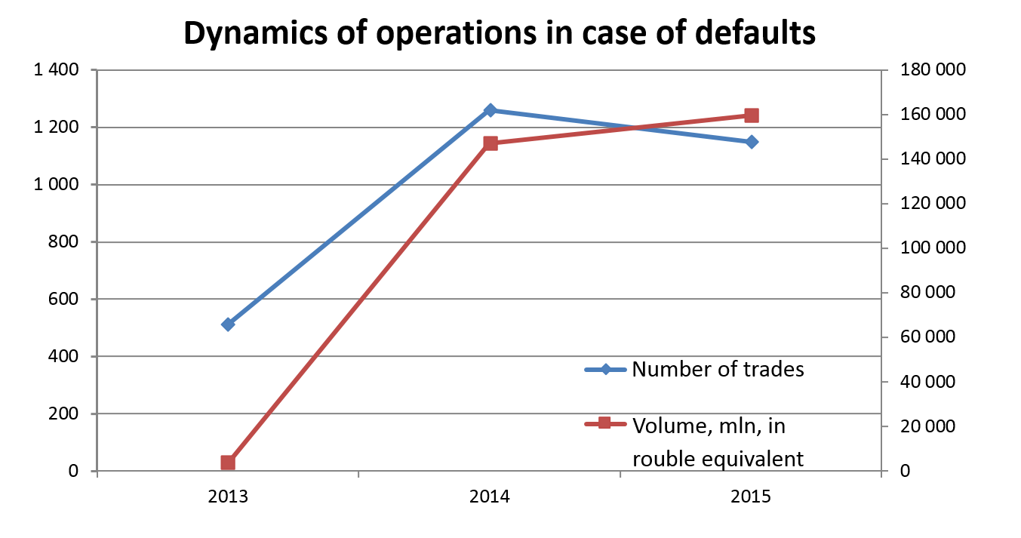

The increasing financial market volatility and, as a result, the increasing rates for the collateral posted by clearing participants in order to participate in the trading, caused NCC's liabilities to grow in all currencies in the first quarter of 2015. Throughout the year, the volumes of collateral posted by clearing participants were decreasing, except collateral in euro, which is, most probably, due to negative rates for this currency.
Due to the above factors, NCC's liability base changed as follows:

01.01.2015
Source | RUB, mln | USD, mln | EUR, mln | Equivalent, RUB
FX market | 104,568.278 | 10,608.832 | 4,712.276 | 1,023,453.866
Derivatives market | 63,194.016 | 585.504 | 139.206 | 105,647.226
T+, REPO with CCP | 28,779.687 | 181.711 | 35.700 | 41,422.265
Equity | 38,542.136 |  |  | 38,542.136
Total | 235,084.117 | 11,376.047 | 4,887.182 | 1,209,065.493

01.01.2016
Source | RUB, mln | USD, mln | EUR, mln | Equivalent, RUB
FX market | 56,663.932 | 5,045.722 | 6,369.871 | 932,070.658
Derivatives market | 27,233.653 | 544.822 | 171.511 | 80,610.698
T+, REPO with CCP | 25,791.617 | 200.888 | 49.178 | 44,352.226
Equity | 54,179.568 |  |  | 54,179.568
CCP’s dedicated capital | 7,266.498 |  |  | 7,266.498
Total | 171,135.268 | 5,791.432 | 6,590.560 | 1,118,479.656

Against the backdrop of sharp increase in liabilities in the beginning of the year, major attention was paid to forming an optimal asset structure securing both profitability of operations and unconditional fulfillment of obligations in case if liabilities decrease. This goal was achieved primarily by increasing the volume of interbank loans in Russian roubles, mostly short-term ones, as well as by creating additional immediate t liquidity by increasing balances in correspondent accounts. For example, the average volume of interbank loans (including SWAP operations) in the first quarter of 2015 exceeded 49 bn roubles, which was almost 30% higher than the year 2014 average. As a result, the decrease in liabilities which started in the second quarter was fully compensated with liquidity. At that, despite the increased level of immediate liquidity, the Bank still earned significant income in the first quarter.
In 2015, as part of support of its clearing activities, NCC continued transactions with precious metals. Throughout the year, the Bank conducted Location SWAP operations in gold in the amount of 1,462 kg and purchase and sale operations in physical gold in the amount of 1,451 kg.
In 2015, to increase yield on its currency assets, NCC performed reverse REPO operations. The average annual volume of such operations in US dollars and euro approximated 26 bn in rouble equivalent.
In 2015, in the environment of financial market instability, NCC paid significant attention to improving the credit quality of assets, and primarily the securities portfolio. In particular, an objective was set to ensure, throughout 2015, that the portfolio contained bonds with long-term issuer rating of at least BB (rated by Standard & Poor's or Fitch Ratings) or Ba1 (rated by Moody's Investors Service), which is one step higher than the requirements of the Bank of Russia for central counterparties, laid out in the Ordinance of the Bank of Russia dated 03 December 2012 No. 2919-U “On assessment of the quality of management of the credit organization performing central counterparty functions”. As a result, as of 01 January 2016, the share of bonds of the issuers with rating of at least BB equaled 99.5% of the portfolio.
Another field of improvement of credit quality was the increase of the share of bonds of the Russian Federation. For example, the share of government bonds in roubles and foreign currencies in NCC's portfolio grew by over 17% (62.9% as of 01 January 2016 vs. 45.7% as of 01 January 2015).
Another measure improving credit quality was to maintain low duration of non-government bonds. Throughout 2015, the duration of sub-federal, corporate and bank bonds was not longer than 0.75 of the year.
Despite gradual decrease in financial market volatility expected in 2016, NCC, in course of financial operations, will continue paying special attention to lowering the risks of the asset portfolio – first of all, credit risk and market risk, which will be especially important after introduction by the Bank of Russia of stricter requirements as to mandatory ratios of banks in terms of calculation of risks for various financial instruments.
It is expected that in 2016, there will be stronger influence of the currently shaping trends of growing restrictions on correspondent accounts in foreign currency, associated with the sanctions against Russia, regulatory requirements towards foreign banks, and negative interest rates. This will require additional measures to adjust the network of correspondent accounts for the purpose of minimizing the time spent and financial costs of clearing settlements. Moreover, further expansion of the range of financial instruments cleared by NCC, primarily in the FX market and securities market, will affect both the quantity and volume of financial market operations, especially in the default management field.

Risk management, including measures aimed at maintaining high management quality of NCC as a CCP

- Compliance of risk management system with regulatory requirements and international standards

NCC, functioning as a central counterparty, clearing organization and commodity delivery operator (hereinafter CDO) in the markets of the Moscow Exchange Group, performs its activities using a state-of-the-art risk management framework (RMF), complying with the international standards, and provides to the participants the clearing services that ensure efficient use of the funds transferred to the market.
Based upon its functions and objectives, NCC has a specific risk structure consisting of the following interconnected groups:
- risks inherent in NCC as central counterparty and clearing organization;
- risks of banking activities;
- CDO risks.

NCC’s risk management framework covers the following range of risks:
- central counterparty risk (CCP credit risk);
- custodial risk;
- credit risk;
- market risk;
- liquidity risk;
- operational risk;
- strategic risk;
- commercial risk;
- legal risk;
- regulatory risk;
- reputational risk.

NCC’s key objectives are to decrease risks in the financial system and to maintain stability in the serviced segments of the financial and commodity markets. The achievement of these objectives is facilitated by implementation of a state-of-the-art risk management framework meeting the international standards, whereby NCC conducts a comprehensive analysis of the risks arising in course of performance of all types of activities.
To ensure its operational reliability, NCC applies the risk management methods stipulated by the requirements of the Bank of Russia, recommendations of the Basel Committee for Banking Supervision, as well as international standards of the Committee on Payment and Settlement Systems of the Bank for International Settlements and the Steering Committee of the International Organization of Securities Commissions (CPMI-IOSCO) for systemically important infrastructural organizations.
In the reporting year, NCC’s activities aimed at the improving its risk management framework were focused on consistency with the requirements of the Ordinance of the Bank of Russia dated 02 December 2012 No. 2919-U “On the management quality assessment of a credit institution performing central counterparty functions” (hereinafter the Regulation No. 2919-U); to this end, in particular, NCC developed and implemented the mechanism of dedicated CCP capital as an additional line of defense.
Also, in order to ensure compliance with the Bank of Russia Regulation No. 463-P dated 12 March 2015 “On the requirements for risk mitigation in clearing operations and the requirements for a document (documents) stipulating measures aimed at reducing credit, operational and other risks, including risks related with the combining of clearing operations with other activity”, NCC developed and registered with the Bank of Russia a single document governing the processes for managing all risks attributed to NCC’s activities – rules for organization of the risk management framework. The document contains general provisions determining the framework for managing the risks inherent in the activities of NCC as a clearing and credit organization and CDO, and a description of the procedures for identification, monitoring and control of risks, the measures for mitigation of risks, and criteria for application of such measures.
In 2015, pursuant to the Ordinance of the Bank of Russia No. 3624-U dated 15 April 2015 “On Requirements for Risk and Capital Management Frameworks of Credit Institution and Banking Group”, NCC started implementation of internal capital adequacy assessment process (ICAAP), including the development of the following internal documents:
- strategy of risks and capital management, aimed at harmonization of the process of managing risks associated with NCC’s banking activities and its relation to capital adequacy management;
- the Bank’s risk appetite statement for the year 2016, which sets forth the thresholds for quantitative and qualitative indicators of the level of significant risks for the forthcoming year pursuant to quarterly monitoring;
- methodology of the Bank’s economic capital assessment, containing the description of the approaches used by NCC to evaluate the required capital to cover the most significant risks both at the individual and at the aggregated level, including the calculation of additional capital reserves.
The improvement of methodology of the processes associated with managing risks and capital management remains one of the most important elements of NCC’s activities.
- Managing risks inherent in clearing and CCP activities
In 2015, the development of NCC's risk management system was primarily focused on ensuring financial stability and reliability of the Bank as a clearing organization and central counterparty, and was carried out in the following main directions:
- ensuring adequacy of financial resources for settlements under regular and extreme market conditions;
- setting up arrangements protecting against potential losses in case of the clearing members' default;
- improving risk assessment methodology required for NCC to provide new clearing products and expand the range of cleared instruments;
- implementing measures to ensure that current activities of NCC comply with the Bank of Russia’s requirements for the central counterparties whose management quality of has been recognized as “satisfactory” in accordance with provisions of the Ordinance No. 2919-U;
- providing information transparency which allows the clearing members to adequately assess risks, and helps supervisory authorities to control their activities efficiently.

Margining system of clearing members’ trades

NCC uses various models to determine collateral requirements, depending on the specific market. The model for determination of collateral requirements takes into account the specifics of instruments and, accordingly, is applied with minor differences accounting for the markets specifics.
In the FX market, securities market and commodities markets, due to linearity of instruments relative to the risk factors, a simplified approach is used, which features 2 scenarios for each instrument (growth and downturn), also taking into account the size of the position, by means of concentration limits.
The set of scenarios used in the derivatives market is chosen accounting for possible presence of non-linear instruments in the position, and, therefore, the set of spot risk scenarios expands to 23, and also the scenarios of possible change of implied volatility are considered.
In the Standardized OTC Derivatives Market NCC also used the scenarios of interest rate curves / implied volatility curve shifts determined using the principle component method (shift – twist – butterfly).
The scenarios used in the margining models are calibrated using historical data, and also considering the potential scenarios of price movements that are not yet reflected in historical data, so as to secure in all markets at least 99% confidence probability for the required collateral size.
The types of assets accepted as collateral also vary, depending on the specific market:
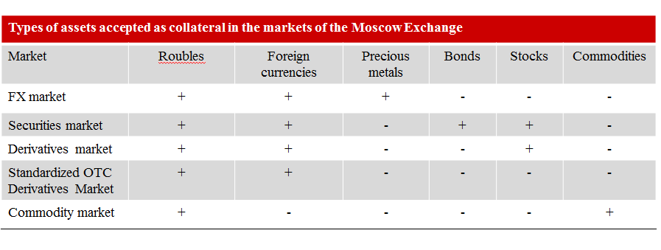

In 2015, the following most significant changes were made, expanding the opportunities for trading and clearing members in execution of exchange trades and OTC trades with NCC as central counterparty:
- in the securities market, the Bank implemented the REPO with CCP, with settlements in US dollars and euro for the time period of up to one week, expanded the list of securities admitted to trading without full prefunding, owing to the differentiation of securities into securities accepted as collateral and securities admitted to trading without full prefunding;
- in the derivatives market, clearing participants were enabled to control the risks of expiration of options on client positions;
- in the securities market, in Russian sovereign bonds (OFZ) segment, settlement cycles T0 and T+2 were replaced with the single settlement cycle T+1 with partial pre-posting. The settlement cycle T+1 enables to reduce the market participants’ costs of funding operations in the government debt market, increase the volume of operations via partial prefunding under the trades, and improve operational efficiency of the market makers, thus facilitating the growth of liquidity in the on-exchange Russian sovereign bonds (OFZ) market;
- in the Standardized OTC Derivatives market, a margining algorithm was approved for the portfolios which include options;
- a methodology for calculation of stress-collateral for the derivatives market, securities market, FX market and precious metals market was approved;
- the Bank launched exchange trading in forward contracts whose underlying asset is commodity (soft wheat). These operations use the margining system similar to the margining system applied in the FX market and securities market.

CCP safeguard structure

In 2015, a new CCP safeguard structure was developed and implemented, aiming to ensure reliable and transparent interaction with the clearing members, and guaranteed maintenance of NCC financial stability when it acts as a CCP in any market situation. The newly developed safeguard structure conforms to the international operating standards for central counterparties and includes the following novelties:
- a unified members’ default protection system for all markets of Moscow Exchange Group;
- formation of CCP’s dedicated capital used in the event of the clearing member’s default, prior to using the resources of guarantee funds;
- maintenance of the minimum level of NCC’s capital, guaranteeing continuity of services to clearing members even in the event of emergency;
- mechanism for limitation of CCP liability when other resources of the safeguard structure exhausted;
procedure for replenishment of dedicated capital of NCC and guarantee funds. CCP’s new safeguard structure is described in the figure below: 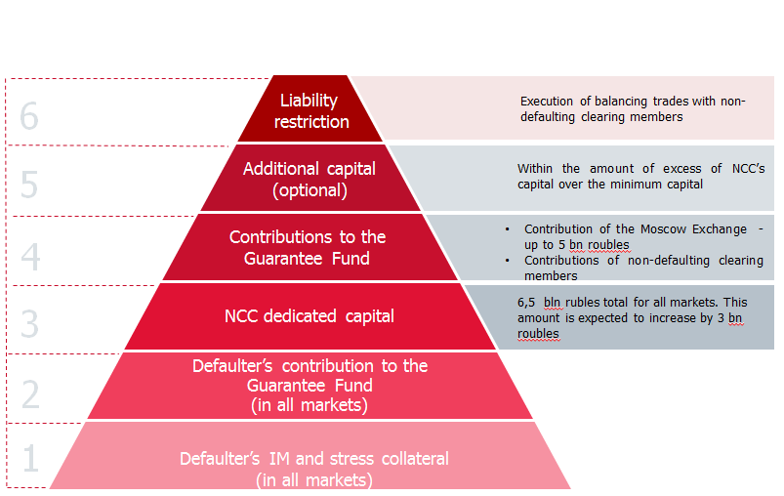

According to the international operational standards for clearing organizations – central counterparties, the level of risk coverage by collective funds is considered to be sufficient provided that, within a short period of time, these resources can cover maximum risk for at least one or two default positions. NCC aims to cover maximum risk arising from default of any 2 or 3 clearing members, which exceeds the requirements of the international standards.
In order to provide additional protection for the non-defaulting clearing members their contributions to the Guarantee Fund are used only when the amount of total debt of the defaulting clearing members to NCC exceeds the maximum acceptable value.
In 2015, guarantee fund for the FX market and precious metals market was formed. Therefore, as of now in all serviced markets of Moscow Exchange Group, guarantee fund may be used as an instrument to cover losses in the event of clearing members’ default. The size of guarantee funds as of 01 January 2016 is provided in the table: below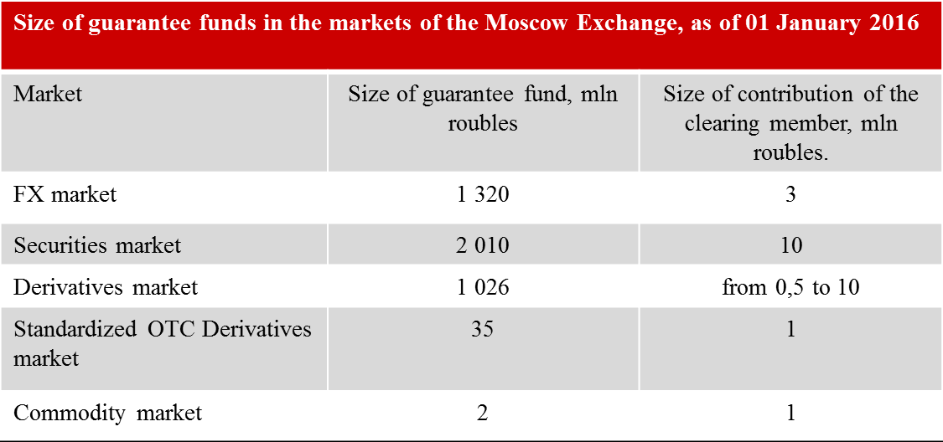
In addition, the Bank performed unification of the procedure for recording of resources of the guarantee funds of the FX market and precious metals market, securities market, derivatives market and commodities market, and the range of assets accepted as collateral to guarantee funds, creating additional preconditions for more efficient and convenient use of own funds by the clearing members.
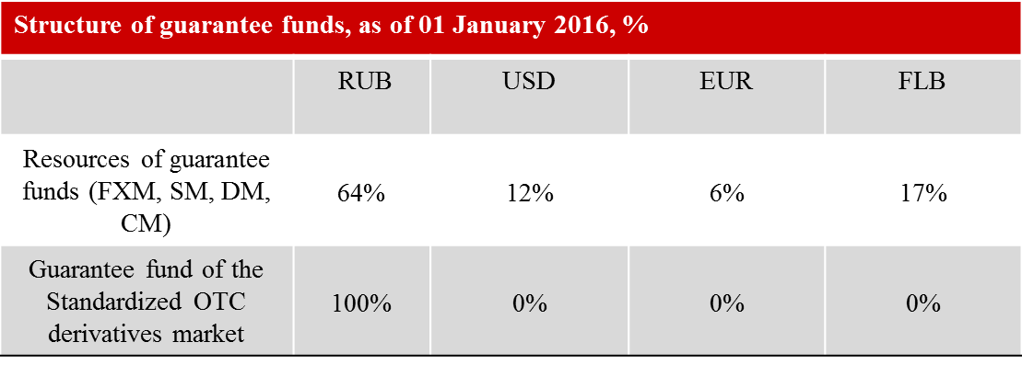
Monitoring of financial condition of the clearing members
NCC uses internal rating system as an efficient instrument for monitoring financial condition of clearing members and counterparties on active trades. The use of formalized internal ratings enables prompt response to deterioration of financial condition of the clearing members and counterparties, as well as establishment of limits for active trades and making adequate provisions for possible losses on risk-bearing transactions.
Assignment of internal ratings is carried out in accordance with NCC's current Methodology of determination of internal ratings of counterparties (issuers) and includes the following elements:
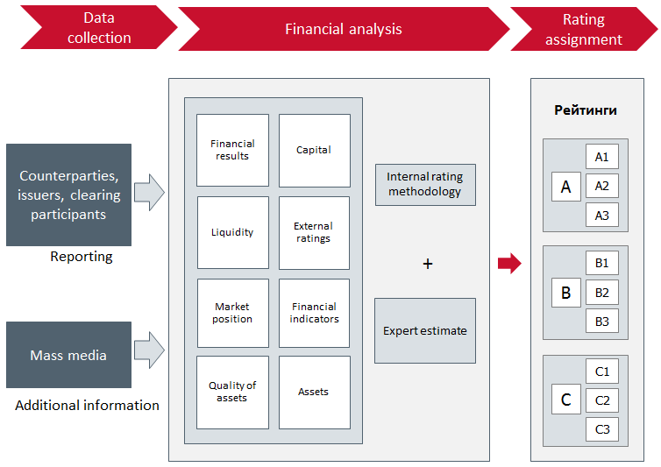
Internal ratings are based on the financial reporting and other information about the clearing participants and counterparties, which is significant in terms of assessing the risks assumed by them. Internal rating represents a total score of financial and non-financial values and can be adjusted upon the result of expert assessment (taking into account the information on ownership structure, counterparty’s business development, market positions of the clearing participant in certain market segments, dynamics of prices on stocks issued by them, and other relevant information).
As of 01 January 2016, NCC’s internal rating system covered 745 organizations. The classification according to the types of rated clearing participants and NCC’s counterparties as of 01 January 2016 is provided in the table below:

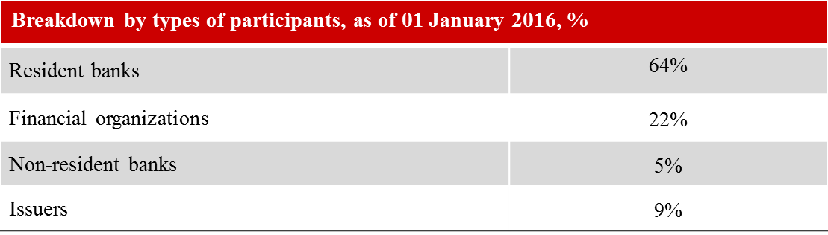

I. Managing banking risks
NCC, due to its special status and types of activities, follows a conservative asset management policy in allocation of free cash.
The major elements of managing risks arising in course of banking operations include:
- assets and liabilities portfolio management;
- monitoring of financial condition of counterparties;
- establishing limits;
- making provisions for possible losses to cover risks;
- refusal to bear certain types of risks.
Credit risk management
Relative to NCC’s banking activities, credit risk arises as a result of NCC’s investment operations.
The credit risk management process is briefly presented in the figure below:
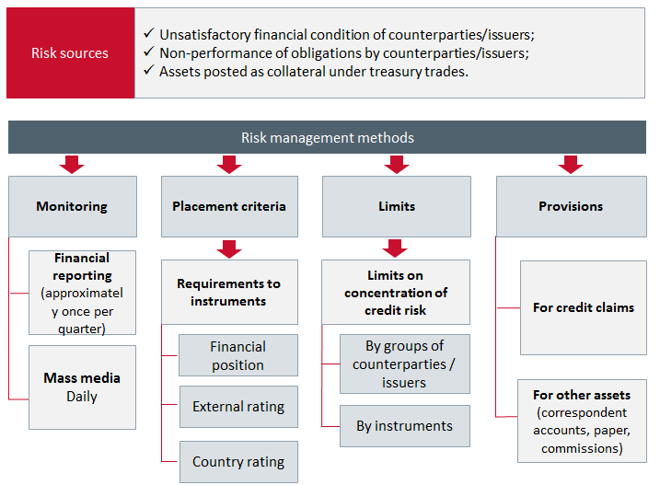
The investment activity of NCC, the criteria for selection of counterparties and instruments in allocation of free cash, as well as maturities taking account of market liquidity of the instruments are regulated by the Bank Treasury Policy.
The main provisions of NCC’s investment policy ensure sufficient return on assets at moderate risk level.
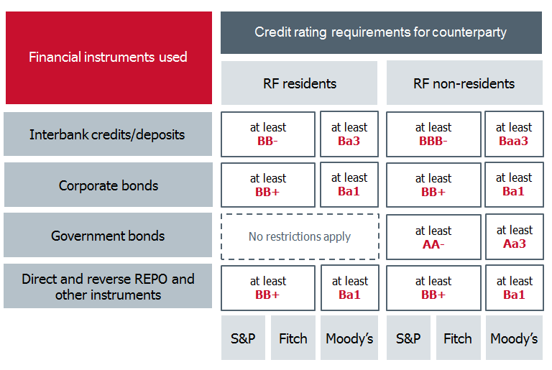

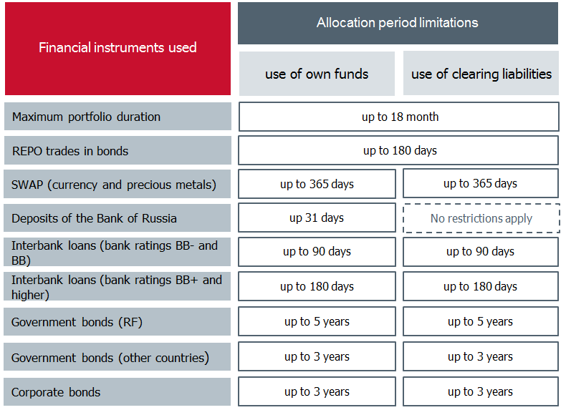

The cornerstone of control of credit risks arising in course of cash allocation is the limiting of treasury operations. The existing system of limits enables limiting of the volume of risks assumed by NCC to the level corresponding to the guaranteed performance of regulatory requirements of the Bank of Russia and the Treasury Policy of NCC.
As of 1 January 2016, the major portion of NCC's assets exposed to credit risk comprised the funds placed on correspondent accounts with credit institutions, mainly in the major foreign banks and the most reliable Russian banks. The largest volume of assets was placed on correspondent accounts with JP Morgan Chase Bank and its subsidiaries due to their performance of functions of settlement banks in the on-exchange FX market of Moscow Exchange Group.
Information on distribution of NCC’s aggregate securities portfolio by sectors of debt issuers, as well as the grouping of assets by the level of their S&P international rating is shown in the diagram:

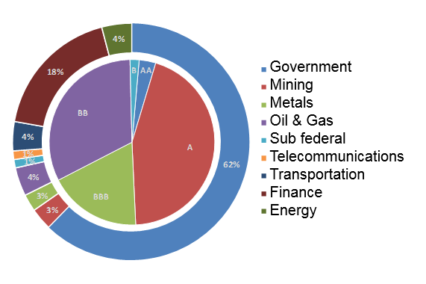In accordance with the regulatory amendments to the procedure for making provisions for possible losses on loans, loan and similar debts and to the procedure for making provisions for possible losses, which became effective on 01 November 2015, NCC’s requirements under operations related to clearing activities and performance of central counterparty functions shall not be covered by provisions. Therefore, provisions for clearing operations and operations related by the Bank’s functioning as central counterparty are not formed, and the value of received collateral is not accounted for. Owing to high quality of assets, capital adequacy ratio (N1.0) as of 1 January 2016 was 13.48% with the regulatory minimum of 10%, which clearly confirms financial stability of NCC.
Managing liquidity risk
The conservative asset management policy contributed to maintenance of the liquidity level sufficient to fulfill NCC payment obligations, primarily, as the CCP. The liquidity management is aimed at ensuring NCC's ability to perform its obligations under normal market conditions and in cases of unforeseen emergencies without suffering unacceptable losses or risk of harming its business reputation.
NCC’s liquidity ratios exceeded regulatory ratios for credit institutions significantly in 2015, as shown in the table below:

Fulfillment of liquidity ratios, as of 01 January 2016, %
Liquidity ratios | Limits set by the Bank of Russia | 01.01.2016 |  | 01.01.2015
Immediate liquidity ratio (N2) | Over 15% |  | 94.06 | 88.25
Current liquidity ratio (N3) | Over 50% | 103.8 |  | 102.89
Long-term liquidity ratio (N4) | Less than 120% | 2.72 |  | 0.95

Liquidity risk management includes the following procedures:
- forecasting payment flows with breakdown by major currencies and determining the required volume of liquid assets;
- monitoring and forecasting liquidity ratios;
- maintaining immediate, current and long-term liquidity at regulatory levels;
- planning measures to recover the required liquidity level in unfavourable and crisis situations;
- setting limits and restrictions on transformation of cash in other types of assets: on transactions with securities, depending on the type and maturity of securities, limit of open FX position;
- composing an optimal structure of assets in accordance with the liabilities;
- taking into account the maturities of raised funds and their volumes when allocating assets in financial instruments;
- analysis of negative scenarios of liquidity shortage; evaluation of the framework for responding to this risk; improvement of tools and methods of liquidity management.

NCC performs liquidity management in real time on the basis of the payment calendar by means of measures to optimize cash flows, improve operations regulations of active operations, settlements and correspondent relations.
Liquidity status is assessed on the monthly basis by means of liquidity gap-analysis (analysis of assets and liabilities by maturities) and calculation of liquidity shortage (excess) and accruing liquidity shortage (excess) ratio by maturities, taking into account the refinancing instruments. The detailed analysis of liquidity based on NCC’s internal models is performed by means of the precise adjustments of the accounting data in terms of composition, amounts and maturities of assets and liabilities.
Monthly liquidity ratios monitoring shows that there was no shortage of liquidity in 2015 within all periods, and the minimum liquidity ratio did not fall below 5% for the period of up to 1 year as shown in the following diagram:

Liquidity risk indicators as of 01 January 2016
(assessment on the basis of the Bank’s internal models)
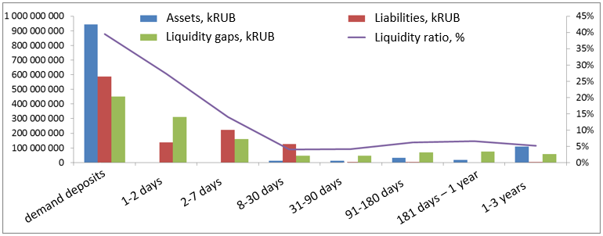
Market risk management

The CCP's activity is exposed to market risk only in case of credit risk event. Therefore, market risk management is performed as part of the range of credit risk management measures.
For the purpose of quantitative assessment of market risk for various markets where NCC acts as a CCP, the methodology was developed to be used, in particular, to determine the volume of claims to the size of collateral posted by the clearing members.
The major purpose of market risk management in allocation of temporarily free cash is optimization of the risk/return balance and minimization of losses in case of unfavourable events. To this end, NCC:
- diversifies its securities portfolio (by maturities and issuers’ industries);
- sets maximum expiration dates for security investments;
- sets maximum limits of investments in securities (for the entire volume of investments, types of investments, and issuers);
- performs classification of debt obligations and securities by risk groups; and
- forms provisions for possible losses from securities transactions, unless such securities are revaluated at fair prices.

NCC is exposed to interest risk on securities and financial derivatives sensitive to interest rate fluctuations, and on derivative trades in securities sensitive to interest rate fluctuations, as shown in the table below:

NCC’s exposure to market risk as of 01 January 2016, kRUB
 | 01.01.2016 | 01.01.2015
Interest rate risk | 5 875 823 | 3 366 335
General interest rate risk | 1 806 441 | 469 676
Specific interest rate risk | 4 069 382 | 2 896 659
Securities market risk | 0 | 0
Currency risk | 0 | 0
Interest rate risk, % of capital | 10.8% | 8.7%

As of 01 January 2016, the size of interest rate risk amounted to 10.8% of the Bank’s capital (equity) (vs. 8.5% as of 01 January 2015).
Interest rate risk is calculated as the sum of general interest rate risk associated with unfavourable change in current (fair) value of securities and financial derivatives, as a result of the market fluctuations of interest rates, and of the specific interest rate risk, due to the factors related to the issuer of securities, given the time period to expiration and taking into account the currency in which the securities are denominated.
There is no equity risk, as there are no equity securities in the Bank’s securities portfolio. NCC is exposed to currency risk in case of unfavourable exchange rate movements. As of 01 January 2015 and 01 January 2016, open positions in foreign currencies and precious metals accounted for less than 1% of capital (equity), and therefore NCC is not sensitive to currency risk. Throughout 2015, the size of market risk was considered as not generating potential losses which would threaten NCC’s financial stability.

IV. Stress testing of financial stability

The stress testing of NCC’s financial stability is aimed at decreasing risks to acceptable level determined by the duty to perform Russian financial market infrastructure functions - maintaining stability in the serviced segments of the financial market, providing to the clearing members the clearing services enabling efficient use of the funds allocated to the market.
In 2015, the comprehensive stress testing of NCC’s financial stability was conducted in accordance with improved methodology, which contributed to higher reliability in substantiation of adopted strategic and operational business solutions in non-standard market conditions. NCC’s stress testing involves assessment of risks inherent in CCP operations, including credit risk, market risk and liquidity risk, and the traditional risks attributable to banking activities.
CCP risk determines the size of losses caused by non-performance, untimely or incomplete performance by the defaulting clearing members in the markets of the Moscow Exchange of their financial obligations to the CCP.
The Bank uses the model of simultaneous settlement of the largest default net positions of counterparties. In determining the number of clearing members’ defaults, NCC takes into account the recommendations issued by CPMI-IOSCO for central counterparties.
NCC conducts reverse stress testing to determine the values of risk factors whereunder financial stability indicators assume critical (minimum/maximum acceptable) values, given the need to comply with prudential requirements of the Bank of Russia.
Financial stability stress testing is conducted both in respect of analysis of sensitivity to certain risk factors which may result in possible CCP’s losses, and in respect of the simultaneous effect of the pre-determined set of risk factors, enabling to evaluate adequacy of the CCP's’ financial resources in crisis situation.
NCC performs validation of the CCP stress testing models. In case of the significant change of market conditions, stress parameters are revised promptly.
The results of the stress testing conducted in 2015 evidence that NCC is able to maintain financial stability without any threat to operational continuity, determined through sufficiency of risk coverage sources, in single and multiple shock scenarios.

Operational risk management

The provision of NCC’s operational continuity, including the smooth functioning of its own systems and processes, was one of the main priorities in the activities of the Bank as a financial market infrastructure that plays an important stabilizing role. This objective was largely achieved through effective implementation of the Bank’s operational risks management system, which is based on its multilevel structure, transparency of functions and managing bodies, and specialized departments, which fully corresponds to the world’s best management practices.
Operational risk is one of the most significant risks for NCC due to the specifics of operation as a clearing centre and central counterparty in the financial markets of PJSC Moscow Exchange. The operational risk management system has been built taking into account the recommendations of the Bank of Russia, Basel Committee on Banking Supervision, and CPMI-IOSCO.
The operational risk management process includes the following stages:
- collecting data on the operational and legal risk events occurred in the Bank’s subdivisions;
- collecting and analyzing data on operational risk events occurred in other organizations similar to the Bank in terms of their activity profile;
- identifying operational risks for new products and processes;
- identifying potential operational by means of self-assessment procedures;
- analyzing and assessing the identified operational risks;
- monitoring operational risk by means of the system of operational risk indicators;
- developing measures to handle operational risk and to control the implementation of measures of operational risks mitigation;
- conducting checks of NCC’s resilience to failures of operational information systems at least once per year;
- providing professional development trainings for employees on operational risk management issues; and
- policy of separation of access rights in data entering and processing, decreasing the risk of unauthorized or erroneous acts of employees of the relevant NCC subdivisions.

Operational risk is mitigated primarily through the use of reliable hardware of exchange infrastructure, information and technology systems, multi-level control of operational procedures and high qualification of personnel.
The structure of the risk management system comprises the Supervisory Board, CEO and the Executive Board, the employee in charge of operational and strategic risk management, and other employees of the organization. The Supervisory Board determines the key principles of operational risks management, including integration of risk management system into the decision-making process and involvement of all company employees in the risk management process. Executive bodies provide management structure with unambiguous responsibility lines and application of established principles at all levels of the organization.
Being a qualified central counterparty, NCC submits the reports to the Bank of Russia on the list of registered incidents and uncovered operational risks on a monthly basis.
NCC’s operational risk management system implies collection and registration of data on operational risk events and real or potential losses related to them. The operational risk assessment is conducted in course of collecting data on the cases of operational risk events, as well as in course of the operational risk self-assessment procedures. The results of such self-assessment are reviewed by the Executive Board.
At the same time, in interaction with the Authorized Employees in legal and reputational risk management functions, operational risk events are assessed in terms of their influence on the level of these types of risks. One of the important operational risk management objectives is to ensure maximum possible involvement of the Bank’s employees in the operational risk management process.
The comprehensive approach to mitigate the operational risks (personnel, processes, systems) implemented by NCC implies, in particular, the implementation of the system for determination of process automation priorities (with risks taken into account), performance of regular risk audit of business processes, maintenance of current accounting of information assets (information systems, facilities, channels of communication), reserving of communication channels, and implementation of project and service approach in the divisions’ operations.
The Bank mitigates operational risk through preventive and corrective internal and external control activities, which include, in particular the implementation of new access control procedures, software and hardware; separation of rights of users/administrators of information systems, data backup, analysis of the existing control measures and development and implementation of the new control measures.
The Bank performs regular analysis of key processes, which results in implementation of new technologies decreasing the level of operational risk. In case of launching of new products and services, the Bank conducts a comprehensive multifactor analysis of the project, including assessment of operational risks.
For the purpose of improving the framework for operational risk management in the Bank, in 2015, NCC’s Supervisory Board adopted a revised Operational Risk Management Policy. This document describes the approaches to identification, analysis and control of operational risk in more detail.
Special attention is paid to ensuring continuity of the Bank’s activities – key information systems have reserve channels and capacities; information is properly stored in electronic archives.
Performing its functions of a clearing organization and central counterparty, NCC assumes the need to be prepared for any events which can result in suspension of standard operational procedures. The Regulation of the Bank of Russia dated 16 December 2003 No. 242-P “On organization of internal control in credit institutions and banking groups" obliges credit organizations to develop business continuity and recovery plans to be used in case of emergencies. Following the regulator’s requirements, NCC has developed and implemented a state-of-the-art business continuity management system.
In implementation of its business continuity processes, NCC uses the methodology of the international standard ISO 22301 (Social security - Business continuity management systems – Requirements). The major elements of this approach are:
- business continuity policy- the document approved by NCC’s Supervisory Board, regulating the work related to ensuring business continuity within NCC;
- assessment of business continuity risks – the process of identification of risks, their analysis and assessment of their influence on NCC’s business;
- analysis of business effect – this is an analysis of all NCC’s processes in terms of how they can possibly be affected by various types of incidents in the course of time. This analysis is conducted at least annually, covering all structural subdivisions of the Bank;
- crisis management – this is a determination of high-level strategy to ensure NCC's business continuity, including pre-developed arrangements for resolution of various crisis situations;
- business continuity strategy – a developed strategy describing the principles of building short-term, medium-term and long-term business continuity management systems;
- business continuity and recovery plan - a documented procedure to be used in case of an emergency. The plan contains the list of measures to maintain critical business functions at the pre-determined and agreed level;
- recovery plan – a documented process for recovery and protection of IT infrastructure and systems in case of an emergency;
- incident management – a clearly defined and documented action plan to be used in case of an emergency, in order to minimize the effect on personnel and critical business processes;
- crisis communications – these are the documented priorities in communications in case of an emergency, which contain pre-developed samples to be used for notification in the external and internal environments;
- testing and exercising - an important process developed to determine adequacy, planning quality and organizational efficiency of the business continuity process.

In accordance with the business continuity strategy and based on business requirements, NCC has established alternative sites (geographically separated back-up offices), which are activated in case of realization of the scenario of inaccessibility of the primary sites. To assess NCC's level of maturity in the area of business continuity, the Bank regularly prepares reports on the key indicators of the business continuity management system and presents them to NCC’s management bodies.

Strategic risk management
NCC’s strategic goals are determined as part of the Strategy of Moscow Exchange Group and are connected with achievement of specific objectives related to pursuing the strategic goals set for the Bank.
Strategic risk is the risk of unfavorable change in performance results due to wrong decisions made in course of managing NCC, including the decisions made in course of carrying out, approval and implementation of NCC's development strategy, improper execution of the decisions made, and inability of NCC's management bodies to consider changes in external factors.
NCC’s strategic goals are formed on the basis of the Strategy of Moscow Exchange Group and approved by NCC’s Supervisory Board.
The strategic risk management system takes into account NCC’s risks arising in course of combination of banking and clearing activities with other activities.
NCC’s activities are based on the following principles within strategic risk management:
- the strategy shall reflect the nature, capacity and scale of NCC’s activities;
- altering NCC’s strategic objectives promptly in case of changes in external and internal factors;
- possibility of quantitative assessment of relevant strategic risk parameters;
- regular monitoring of strategic risk parameters size;
- evaluation of risk and preparation of information to make proper management decisions;
- use of independent informational approaches to all significant risks.

For the purpose of strategic risk monitoring, the following monitoring criteria were set:
- monitoring criterion related to impossibility of achieving the defined strategic goals;
- monitoring criterion related to the change in strategic goals.

Strategic risk monitoring is conducted in accordance with the set criteria, by means of the range of qualitative indicators, including:
- unveiling cases of violation of the approved Development Strategy;
- identifying significant deviations from time schedule and/or budget for implementation of strategic projects;
- identifying risks impeding achievement of strategic goals.
The additional tool for managing the strategic risk at the strategy implementation stage is the monitoring of the progress of implementation of the Strategic Initiatives.
Regular reports are submitted to NCC's authorized collective bodies based on the results of strategic risk monitoring, which include:
- data on strategic risk level and dynamics;
- statistical data on key risk indicators;
- results of the programs for identification and assessment of strategic risk;
- report on the progress of implementation of risk mitigation measures;
- other information related to strategic risk management.
The results of managing the strategic risk are considered in the process of strategic planning in accordance with NCC’s strategic goals and the Group Strategy. On the basis of the established current and planned (target) indicators of risk appetite, NCC takes part in strategic goals development.
In 2015 NCC’s Supervisory Board adopted the Strategic Risk Management Policy for the purpose of improving the mechanism for strategic risk management in NCC.

Legal risk management
NCC's legal risk management framework is based on the operational specifics of the Bank, which combines the functions of a central counterparty and a clearing organization in the financial markets of Moscow Exchange Group with the banking operations and with activities of a commodity delivery operator. At that, special attention is paid to the measures for legal risk mitigation in course of performance of central counterparty functions by NCC. In NCC, legal risk factors are common for all types of activities; therefore, for the purpose of arrangement of the legal risk management process, NCC has developed comprehensive legal risk management system for all types of NCC's activities.
For the purpose of managing the legal risk and organizing work on minimization of legal risk in NCC, the Supervisory Board of NCC approved the new version of the Regulation on organization of legal risk management in Bank National Clearing Centre (Joint-Stock Company) (Minutes No. 8 dated 24 December 2015), which takes into account the new requirements of the Bank of Russia to the legal risk management, stipulated in the Regulation No. 463-P dated 12 March 2015 “On requirements aiming to decrease clearing risks and requirements to the document(s) determining the measures aiming to decrease credit, operational and other risks, including the risks associated with combining clearing activities and other activities” and the Ordinance No. 3624-U dated 15 April 2015 “On Requirements for Risk and Capital Management Frameworks of Credit Institution and Banking Group”, as well as the requirements of the Bank of Russia on the need for separation of legal and regulatory risk factors within the activity of a credit institution.
Legal risk management process implies delegation of responsibilities to different levels of NCC’s management bodies, and also to structural departments and employees of the Bank. The system of rights to make decisions in the legal risk management process and control over legal risk management effectiveness comprises several levels: the first is NCC’s Supervisory Board and the Risk Committee of the Supervisory Board, the second is the Executive Board, CEO and the Internal Audit Department, the third level is the Authorized Officer for legal issues, Legal Department, Internal Control Department, Risk Analysis and Control Department, the Authorized Officer for operational risk management, and the forth level is represented by other subdivisions.
In accordance with the internal administrative document, the Bank has appointed the Authorized Officer for legal issues, who is in charge for managing legal risk and framework aimed at mitigation of legal risk. The Authorized Officer for legal issues is directly subordinated to NCC’s CEO, and in its activities he or she is independent form the Legal Department and the subdivisions performing operations (trades) associated with legal risk-taking.
On an ongoing basis, the Authorized Officer for legal issues organizes monitoring of legislation of the Russian Federation, prepares overviews of changes in the legislation of the Russian Federation, regulations of the Russian Federation, judicial practice, and draft regulations of the Russian Federation on the issues relevant to NCC. Such overviews are sent to all interested structural subdivisions of NCC. The heads of the interested structural subdivisions ensure timely implementation of changes in the internal documents of NCC, taking into account the changes in the legislation of the Russian Federation.
In accordance with its internal documents, NCC collects and analyzes information about the facts of legal risk events and monitors legal risk. On a quarterly basis, the authorized officer for legal issues prepares legal risk reports and submits them to the Executive Board of NCC for review and approval. The reporting on legal risk is formed on the basis of the legal risk level assessment indicators introduced by the Regulation on organization of legal risk management in Bank National Clearing Centre (Joint-Stock Company).
To mitigate legal risk, the Bank has developed standard forms of agreements and other internal documents and established the procedure for approval by the Legal Department of the non-standard agreements, operations and other transactions of the Bank.
Major attention is paid to analyzing the claims of the clearing participants and counterparties, and to the measures aimed at prevention of the situations which could result in application of enforcement measures against NCC by the regulatory and supervisory bodies or filing of lawsuits against NCC.

Reputational risk management

In 2015, NCC managed reputational risk (hereinafter RR) on the basis of the regulation on organization of management of this type of risk, approved by the Supervisory Board, developed pursuant to the Regulation of the Bank of Russia dated 16 December 2003 No. 242-P “On organization of internal control in credit institutions and banking groups” and the Letter of the Bank of Russia dated 30 June 2005 No. 92-T “On organization of legal risk management and reputational risk management in credit institutions and banking groups".

Reputational risk is the risk of the Bank's losses due to negative effect on its business reputation of external and internal factors the list whereof is stipulated in the abovementioned letter of the Bank of Russia. In accordance with the classification adjusted for NCC’s business processes, all RR factors are divided into four groups:

- violation of federal laws, regulations, operating standards, norms and instructions of the regulator, and contractual obligations;
- IT systems malfunction;
- personnel faults;
- negative information in the mass media.

In the reporting period, RR was managed on the basis of the system for information and analytical support for the process of managing this type of risk, centered around the developed methodology and rubricator of identification of events occurring in course of NCC’s operations as the reputational risk events and calculation of the level of this risk. In accordance with the methodology approved by the Bank’s Executive Board in 2015, for the purpose of evaluation of the dynamics of changes in RR, a below scale was created where the level ranges represent the best grading scale, featuring division into six levels by extent of reputational risk:
- low acceptable, from 0 to 50 points;
- medium acceptable, from 51 to 150 points;
- high acceptable, from 151 to 300 points;
- low unacceptable, from 301 to 500 points;
- medium unacceptable, from 501 to 700 points;
- high unacceptable, from 701 to 1000 points.

In 2015, in the process of managing RR, major attention was focused on monitoring of all incoming information about the Bank’s activities in order to identify risk events, analyze and evaluate them in terms of their impact on the level of RR and, if necessary, to take measures to avoid/reduce the impact of such events on the organization’s business reputation. The main source of RR events in the reporting year was the operational risk events, especially when such events aroused negative reaction in the mass media. In general, as monitoring shows, identification and assessment of RR events, the dynamics of change of the level of this type of risk in the reporting period persisted within the range of acceptable level. On a quarterly basis, NCC reported to Financial Stability Department of the Bank of Russia on the results of RR management and on fulfillment of the regulator’s recommendations in this field of the Bank’s operation.

In the second half of 2015, NCC prepared implementation of the final stage of creating an automated system for information and analytical support of RR management, which would ensure prompt identification of reputational threats and responding to them in order to prevent/minimize possible damage to the credit organization. This process is planned to be automated in 2016.

Regulatory (compliance) risk management

Regulatory (compliance) risk is the risk of losses arising as a result of non-compliance of NCC’s activities with legislation, Articles and internal regulations.
The specifics of regulatory risk in the context of NCC’s activities as a clearing organization, central counterparty and commodity delivery operator is that NCC may incur expenses (losses) due to the failure of the Bank and its activities to comply with the requirements of the Federal Law dated February 07, 2011 No. 7-FZ “On clearing, clearing activities, and central counterparty”, federal laws, financial market regulations, the Articles and internal documents of NCC related to the abovementioned types of its activities.
In late 2015, the internal documents and everyday practices were adjusted to implement the separation of legal and regulatory risk-factors in the Bank’s activity, on the basis of the amendments introduced by the Regulation dated 24 April 2014 No. 3241-U to the Regulation of the Bank of Russia dated 16 December 2003 No. 242-P “On organization of internal control in credit institutions and banking groups".
In order to adjust the system for managing the regulatory risk in accordance with the new requirements of the Bank of Russia, the Bank, by resolution of its Supervisory Board, approved the Regulation on organization of regulatory risk (compliance risk) management dated 24.15.2015 (Minutes No. 8), and the internal documents on anti-corruption policy dated 24 September 2015 (Minutes No. 4) and on the procedure for mitigation of the conflict of interest dated 26 June 2015 (Minutes No. 2).
Regulatory risk management is conducted by the internal control service, whose list of objectives includes performance of the following actions to prevent losses from regulatory risk event:
- monitoring legislation;
- interacting with regulatory bodies on the issue of development of new regulations;
- identifying regulatory risk in the existing and planned internal procedures;
- analyzing the best internal control practices.
For the year 2016, the Bank set additional limits and internal control over the qualitative (non-financial) risks of NCC in accordance with the Key Risk Appetite Indicators and the Risks and Capital Management Strategy, developed in order to organize internal capital adequacy assessment process (ICAAP).

Internal control system

NCC performs internal control in accordance with the Federal Law dated 02 December 1990 No. 395-1 “On banks and banking activity”, Federal Law dated 07 February 2011 No. 7-FZ “On clearing, clearing activity, and central counterparty”, Regulation of the Bank of Russia dated 16 December 2003 No. 242-P “On organization of internal control in credit institutions and banking groups”, and the Order of the FSFR of Russia dated 13 August 2013 No. 13-72/pz-n “On approval of requirements to arrangement of internal control of a clearing organization and to the document establishing the internal control procedure in a clearing organization”, subject to the nature and scale of conducted operations, level and combination of assumed risks, in its roles of both the central clearing counterparty and the Bank, which exert mutual influence upon each other.
Internal control is exercised for the following purposes:
- efficient financial performance of NCC in banking operations and other transactions, performance of the functions of a clearing organization and central counterparty, efficient management of assets and liabilities, including safe custody of assets, management of banking risks / central counterparty risks;
- accuracy, completeness, objectivity and timeliness of preparation and submission of financial, accounting, statistical and other reports;
- information security, i.e. protection of NCC’s interests in the information field, which is the totality of information, data infrastructure, entities collecting, forming, disseminating and using information, as well as the systems regulating the relations arising in this field;
- compliance with requirements of the legislation of the Russian Federation, Articles of NCC, and internal documents of the Bank;
- prevention of NCC’s involvement and participation of its employees in unlawful activities, including legalization of criminal income (money laundering) and financing of terrorism, and in performance of questionable operations;
- mitigation of the risk of the Bank’s losses due to application of sanctions and/or other disciplinary measures by supervisory bodies, including the same due to non-compliance with the legislation of the Russian Federation, Bank’s internal documents, and standards for self-regulated organizations, as well as timely provision, in accordance with legislation of the Russian Federation, of information to the state authorities and the Bank of Russia, maintaining NCC’s effective system of internal control related to combating legalization of criminal income (money laundering) and financing of terrorism, at the level sufficient to manage the risk of legalization of criminal income (money laundering) and financing of terrorism.
The efficiency of NCC’s internal control system is achieved using the following methodology:
- control procedures implemented at all management levels;
- periodical inspections of compliance of all activity areas with established policies and procedures;
- ensuring that the control procedures are embedded in NCC’s everyday operations;
- subsequent control of the completed transactions;
- ensuring separation of functions and absence of the conflicts of interest in performance of duties by the personnel;
- ensuring conformity of the conducted operations to the effective legislation of the Russian Federation and regulations of the Bank of Russia;
- ensuring prompt submission of necessary information to the relevant NCC employees;
- maintaining the required level of security of information systems;
- daily monitoring of the riskiest transactions;
- external and internal audit of the internal control system;
- performance of regular control of efficiency of the measures taken by the subdivisions and management bodies upon the results of inspections, ensuring decrease in the level of identified risks;
- ensuring timely submission to the management and Supervisory Board of the information on material risks and deficiencies of the internal control system.
As of 31 December 2015, the system of NCC’s internal control bodies performing internal control in accordance with their powers defined in the Articles and internal documents of NCC included:
- management bodies of NCC (General shareholders meeting, Supervisory Board, Executive Board, and CEO);
- Revision Commission;
- Chief Accountant (his or her deputies);
- Internal Audit Service (hereinafter IAS). IAS operates under the direct control of the Supervisory Board of NCC. The main objective of the Internal Audit Service is to ensure independent objective assessment of efficiency of internal control, risk management framework, and corporate governance. Based upon the results of an independent assessment of the function of internal audit, conducted in 2015, PricewaterhouseCoopers noted that IAS conducted assessment and monitoring of the internal control system, performing its duties in accordance with the regulations of the Bank of Russia, Moscow Exchange Group and the Bank's business needs.
- Internal Control Service (hereinafter ICS). ICS operates under the direct control of the CEO. In the matters related to compliance with requirements of the legislation on combating unlawful use of insider information and market manipulation, the head of the Internal Control Service is subordinated to the Supervisory Board of NCC. The main functions of the ICS are: identification of compliance risk (regulatory risk) and organization of managing of this risk, control of NCC’s observance of the legislation on combating unlawful use of insider information and market manipulation in accordance with the Federal Law dated 27 July 2010 No. 224-FZ “On combating unlawful use of insider information and market manipulation and on making amendments to certain laws of the Russian Federation”. Also, ICS ensures control of compliance with requirements of the Federal Law dated 07 February 2011 No. 7-FZ “On clearing, clearing activities, and central counterparty”.
- Financial Monitoring Department – NCC’s structural subdivision for combating legalization of criminal income (money laundering) and financing of terrorism, established and operating in accordance with paragraph 2 of Article 7 of the Federal Law dated 07 August 2001 No. 115-FZ “On combating legalization of criminal income (money laundering) and financing of terrorism”.
The CEO by his order appointed the authorized officer (head of the Financial Monitoring Service) – a special officer responsible for implementation of internal control rules for the purpose of combating legalization of criminal income (money laundering) and financing of terrorism in NCC;
- Information Security Service;
- Risk Analysis and Control Department (hereinafter RACD) – a structural subdivision of NCC, whose activity is focused on forming a single and efficient economic risk management system for NCC as a credit organization and clearing centre operating in the markets of Moscow Exchange Group. Also, RACD coordinates and controls the work of all subdivisions (employees) performing the non-financial risk management functions;
- authorized officer for legal issues – the person in charge for managing legal risk and organization of work aimed at mitigation of legal risk. The authorized officer for legal issues acts in accordance with the legislation of the Russian Federation, regulations of the Bank of Russia, Articles, and internal documents of NCC;
- The authorized officer for reputational risk management – a person managing reputational risk and organizing the work aimed at its mitigation. The authorized officer for reputational risk management acts in accordance with the legislation of the Russian Federation, regulations of the Bank of Russia, Articles, and internal documents of NCC;
- The authorized officer responsible for organization of operational and strategic risk management. The authorized officer responsible for organization of operational and strategic risk management acts in accordance with the legislation of the Russian Federation, regulations of the Bank of Russia, Articles, and internal documents of NCC;
- Other structural subdivisions and NCC employees performing internal control in accordance with their powers defined in the internal documents of NCC.
The interaction between NCC’s subdivisions and employees included in the internal control system is illustrated by the scheme below.
Interaction between NCC’s subdivisions and employees included in the internal control system
Общее собрание акционеров

Internal Audit Service
Auditing Commission
Supervisory Board

Общее собрание акционеров

Internal Control Service
Board,
Chairman of the Board

Общее собрание акционеров

Deputy Chairman of the Board

Chief Accountant and his/her deputies
Общее собрание акционеров

Financial Monitoring Service
Risk Analysis and Control Department
Authorized employee for legal matters
Authorized employee for reputational risk management
Authorized officer for operational and strategic risk management
Other NCC units and employees conducting internal control in accordance with powers determined by internal documents of NCC

Technological platform

The quality and continuity of critically important clearing services is largely determined by reliability of the software and hardware complex. In 2015, the Bank continued to modernize and improve the information technology infrastructure, supported functioning of all Software installed in NCC on the level complied with global standards.
In the reporting year, a large scope of works on automation of the processes related to implementation of new services and changes occurring in the Russian financial market infrastructure were performed. The most important from them were the following:
- Creating the system “SWIFT message converter” which is planned to be used in transition to the back-up (alternative to the SWIFT system) channels of interaction with correspondent banks. As a result, by the year end, the Bank had a software which can be used as the alternative communication channels for the purpose of performing clearing obligations and managing liquidity of NCC Bank (JSC). The resolution of this objective improved the Bank’s technological resilience to negative factors of the external environment.
- Launching the WEB - clearing system being a state-of-the-art development of the electronic document interchange system using Web technologies. This has enabled to expand the range of technologies used in the NCC EDI subsystem.
- Developing a two-level access to trading in the markets of the Moscow Exchange.
- Expanding the range of accepted OTC trades with FX swaps and forwards in the SFD market.
- Unifying the settlement technology in all the markets of the Moscow Exchange on the basis of using the Central Counterparty System (CCPS). Settlements in the securities market of the Moscow Exchange were transferred from the FX trading settlement system to CCPS. Thus, by the end of 2015, the Bank’s Legacy system processed only one type of operation - FX trading settlements. As a result, further steps were taken to unify the clearing and settlement technology within NCC's systems.
Throughout the year, the Bank actively worked on the automatization of the processes to comply with the changing requirements in new regulations of the Bank of Russia. A range of tasks related to automation of the IBS “Centaurus Omega” was performed (over 650 updates/fixes were installed in accordance with user requests and orders/instructions of regulations), including:
- Generation of FATCA reporting for the US tax authority (IRS).
- Automation of the tax return generation process.
- Generation of tax registers for FD SWAP trades.
- Automation of the follow-on control of limits for correspondent accounts.
- Automation of deferred income tax in order to fulfil the requirements of the procedure for accounting of deferred income tax.

In 2015, the quantity of users of IBS Centaur Omega grew by 12%. The volume of transactions increased by over 10% up to 81,981,293.
The quantity of recorded entries of counterparties and issuers - legal entities grew by 7% and , reached 3,422, and the same indicator for private individuals increased by 35% up to 6,936.
The development of the ecosystem Softwell NAVIGATOR products was not limited to introduction of new instruments in the SFD market. The following can also be mentioned:
- Implementation of an innovative service FinCAD where risk model is an adjustable parameter (previously risk model was programmed by the software vendor). Risk model caching now occurs in DB, enabling an additional productivity growth.
- Implementation of a specialized monitoring interface for the Bank of RussiaSupervisor. This was achieved by introducing an all-new User type and developing a scheme for access to the Trading and Clearing System NAVIGATOR via the trading network of the Moscow Exchange (and not via the Internet as is the case with other participants).
- Implementation of loading of Bloomberg BVAL quotes for CCPS for the purpose of determining current fair value of the bonds pledged to CCP.
- Replacement of servers of the Data Bus NAVIGATOR – back-up and main servers – for the new ones, with updating of the platform from Windows 2003 + Oracle 10g to Windows 2012 + Oracle 12c.
- Development of integration with IBS “Centaurus Omega”: a function of transmission of additional information on SFD trades was implemented. In particular, it concerned the transmission of TSS under OTC SFD trades and the clearing date as a payment parameter.

The quantitative indicators in the SFD market in 2015 were as follows:
Indicator | Total | New
Active users | 36 | 6
Active logins of Clearing Participants in the SFD Market | 62 | 27
Trades between Clearing Participants and CCP in the SFD Market | 128 | 100
To ensure NCC’s guaranteed reliable access to payment systems of the Bank of Russia and electronic information services of the Russian federal services, a comprehensive testing of specialized NCC systems was conducted at the back-up site (12 Spartakovskaya Street). The specialized NCC systems (payments and reporting to the Bank of Russia) at the back-up site are in the state of readiness for immediate use. To optimize the business processes used in interaction with the payment system of the Bank of Russia, the interface for NCC’s interaction with the regulator’s payment systems was transferred to the uniform high-reliability software “Client of the Bank of Russia, special version”.
The Bank’s software and hardware complex (hereinafter SHC) is located in the two geographically remote data processing centres with full back-up of the most critically important NCC systems.
As part of extension of the potential of existing IT infrastructure, and for the purpose of improving resilience to breakdowns and mitigating operational risks, the Bank bought 19 new, more power servers and commenced the work on creating a new contour for main NCC systems in the new data center of DataSpace Co., having a Tier III certificate. At the same time, Database servers were transferred from the operating system HP-UX to the new, more popular worldwide, operating system Linux, enabling to obtain more efficient technical support from the software manufacturer with lower financial costs, and also upgraded to the ORACLE 12c.
The Bank completed modernization of SHC for generation and storage of electronic archives of the Bank’s trading day, namely commissioning of the software complex Symantec Backup Exec 15 on the platform Windows Server 2012 R2 and modernizing the data storage system HP MSA G3.
The Bank continues development of the ORACLE database management system (DBMS) services. In 2015, the aggregate volume of supported databases (DBs) reached 14.1 Tb, and the number of databases is 38.
NCC continued work on the task of automated placement of risk parameters on its website. In 2015, the function of automated placement of risk parameters for the securities market and FX market of the Moscow Exchange on NCC’s website was implemented.
The stress testing conducted in 2015 demonstrated that the Bank’s SHC was capable of operating under the workload twice the current amount.

Major financial performance results
Major financial performance results as of 01 January 2016 (in thousand roubles)
Equity (capital) | 54,130,884
Net income, total | 29,270,946
Operating expenses | 1,186,620
Pre-tax profit | 28,084,326
Accrued (paid) taxes | 5,437,891
After-tax profit | 22,646,435

Dynamics of changes in financial results (thousand roubles)

Indicators | Change 2015/ 2014 | 2015 | 2014
Interest income |  | 59,095,188 | 20,758,102
Interest expenses |  | 35,963,012 | 9,837,677
Net interest income | 212 % | 23,132,176 | 10,920,425
Changes in provisions for possible losses on loans and equivalent debt |  | 102,550 | -100,161
Net interest income after provision for possible losses | 215 % | 23,234,726 | 10,820,264
Commission income (including clearing fees) | 129 % | 5,900,548 | 4,575,888
Commission expenses | 125 % | 105,524 | 84,248
Net income from transactions with financial assets measured at fair value through profit or loss |  | 151,923 | 923,191
Net income from held-to–maturity securities dealing |  | 0 | 0
Net income from available for sale securities dealing |  | -130,049 | - 1,403,198
Net income from foreign currency transactions |  | 1,449,616 | 5,875,263
Net income from foreign currency revaluation |  | -1,277,140 | -6,125,614
Change of provision for possible losses on held-to-maturity securities |  | 0 | 0
Provisions for devaluation of other assets |  | 41,794 | -40,840
Other operating income |  | 5,052 | 63,527
Net income (expenses) | 200 % | 29,270,946 | 14,604,233
Operating expenses | 116 % | 1,186,620 | 1,021,997
Pre-tax profit (loss) | 207 % | 28,084,326 | 13,582,236
Tax compensations/expenses |  | 5,437,891 | 2,661,291
Profit (loss) after tax | 207 % | 22,646,435 | 10,920,945
Distribution of profit after tax , total, including: |  | 0 | 0
dividends to shareholders |  | 0 | 0
formation and replenishment of reserve fund |  | 0 | 0
Retained earnings (losses), after tax |  | 22,646,435 | 10,920,945

Dynamics of changes in equity (capital) of the Bank and major indicators included in the capital calculation (thousand roubles)

The Bank manages its capital on the going concern assumption, with the view to the need to maintain necessary balance between securing financial stability in any economic conditions, reducing the costs of market participants and providing high return on investment for shareholders.
As a company of Moscow Exchange Group, in the reporting period, the Bank managed its capital, being guided by the objectives determined by the Group Strategy for 2012-2015 in the field of centralized clearing and increasing reliability of the central counterparty. Paying attention to the need to comply with regulatory requirements to the capital of credit organizations, the Bank forecasted its capital amount subject to the rate of growth of operations in the Group’s on-exchange markets, growth in volumes of resources posted by clearing participants to secure performance of trade obligations, and subject to the size of risks accepted in connection with implementation of the Group's top-priority projects involving performance of centralized clearing by the Bank. When forecasting the size of capital and its adequacy level, the Bank also considered the expected dividend payments in accordance with the Group’s dividend policy.
Item | 01.01.2016 | 01.01.2015
Equity (capital) total | 54,130,884 | 38,542,136
including:
Tier 1 capital | 31,346,599 | 27,688,179
Tangible common equity | 31,346,599 | 27,688,179
Additional capital | 22,784,285 | 10,853,957
In the reporting period, the Bank fully met all existing requirements to capital adequacy.

Year | 2007 | 2008 | 2009 | 2010 | 2011 | 2012 | 2013 | 2014 | 2015
Equity (capital) | 715,875 | 2,131,622 | 4,251,640 | 8,126,112 | 9,999,913 | 13,501,400 | 28,839,271 | 38,542,136 | 54,130,884
Profit | 15,258 | 373,478 | 937,956 | 1,738,448 | 3,615,799 | 7,034,380 | 13,350,109 | 20,914,899 | 43,766,172
Authorized capital | 700,000 | 1,735,000 | 1,735,000 | 4,435,000 | 6,170,000 | 6,170,000 | 15,170,000 | 16,670,000 | 16,670,000
Reserve capital | 1,262 | 24,704 | 86,750 | 221,750 | 308,500 | 308,500 | 966,775 | 966,775 | 966,775
Sources decreasing equity (capital), including:
Dedicated capital | 0 | 0 | 0 | 0 | 0 | 0 | 0 | 0 | 6,500,000
CCP capital for coverage of possible losses | 0 | 0 | 0 | 0 | 0 | 0 | 0 | 0 | 766,498

Equity (Capital)
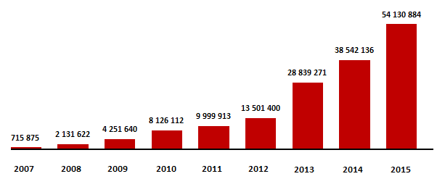

Profit

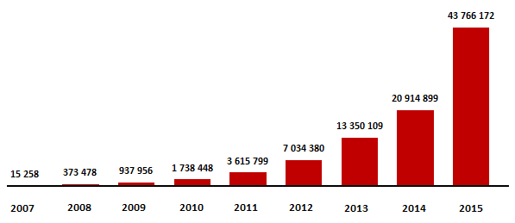

Authorized Capital
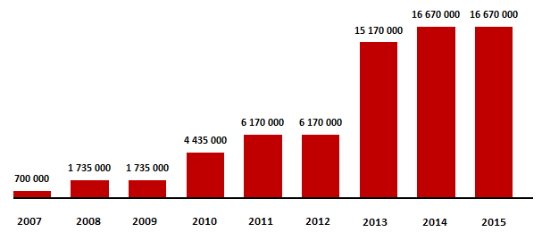

On 01 November 2015, the amendments to the regulations of the Bank of Russia governing central counterparty activity became effective, whereunder the central counterparty must segregate a part of equity (capital) to cover possible losses, whether or not caused by non-performance by clearing participants of their obligations.
In accordance with these amendments, the Bank recorded in separate individual retained earnings accounts the resources intended for the following:
- coverage of possible losses arising from non-performance by clearing participants of their obligations (funds used by the central counterparty prior to the use of the funds posted by non-defaulting clearing participants to the collective clearing collateral) – dedicated capital of the central counterparty in the amount of 6,500,000 thousand roubles;
- ensuring termination or restructuring of the central counterparty, in the amount of 510,999 thousand roubles;
- coverage of possible losses resulting from deterioration of the central counterparty’s financial condition due to decrease of its revenue or increase of expenditures not related to non-performance of obligations by clearing participants, in the amount of 255,499 thousand roubles.
The resources of the central counterparty formed in accordance with requirements of the effective legislation, regulations of the Bank of Russia, intended for coverage of abovementioned losses, decrease the Bank’s equity (capital).
Sources decreasing equity (capital)

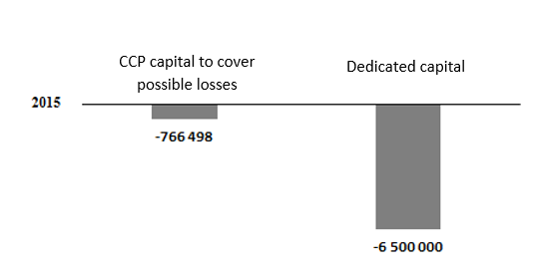

Bank’s human resource management policy
In 2015, the Bank’s human resource management policy paid special attention to the issues of adjusting the Bank’s personnel remuneration policy in accordance with the regulator’s requirements. Among the significant objectives pursued in 2015 as part of the Bank’s human resource management policy, the following may be also mentioned:
- implementation of the project in personnel training focused on the development of management competencies for managers of different levels, which is important for making a contribution to the development of the Bank’s management culture;
- broadening the range of insurance protection for the Bank’s employees and improving the conditions for provision of certain types of social support.

Organizational structure of the Bank

In the reporting period, the number of the Bank’s employees increased by 5 people (or by 3%) as compared to the previous year, equaling 160 employees as of the end of 2015.
In February 2015, Louis Vicente, who had held the position of the Bank’s Managing Director since September 2013, was appointed to the position of the Deputy Chairman of the Executive Board where he supervises the issues of modernization and development of NCC’s risk management framework. In April 2015, Louis Vicente was also elected for membership in the Bank's Executive Board. Thus, the number of members of the Bank’s Executive Board increased to 5.
Significant organizational changes have affected one of the Bank’s key subdivisions – the Clearing Department. To improve efficiency of support for clearing activities, the department’s internal units were reordered by functions – performance of clearing operations and documentation of clearing operations - replacing the previous structure where units were ordered by serviced markets, not by functions. To improve the performance of relevant sectors, two units in the Department were allocated for special performance of functions of promotion and information support for clearing services, and functional testing of specialized software.

Personnel remuneration policy

As part of implementation of its personnel remuneration policy, the Bank aims to provide competitive level of remuneration, i.e. the level comparable with the level of remuneration in the companies comparable to NCC in terms of the scale and specifics of business, in order to be able to hire, motivate and retain highly qualified professionals and managers for the Bank.
Started in previous year, the work on adjustment of the personnel remuneration policy in accordance with the regulator’s requirements was completed by the end of 2015.
The fixed part of remuneration is the basis of remuneration of the Bank’s personnel. The basic remuneration, being an element of the fixed part personnel remuneration, is differentiated by position levels (grades), depending on their importance for the Bank and their contribution to its performance results, also subject to the level and combination of the risks accepted by the relevant employee and his or her level of responsibility.
To achieve consistency between the personnel remuneration system and the Bank’s strategy, nature and scale of conducted operations, its performance results, level and combination of accepted risks, NCC uses financial incentives aiming to connect the size of the variable part of remuneration with contribution of each employee, i.e. to achieve economically reasonable conformity of the employee performance result (aligned with the Bank's objectives) and costs of financial incentives.
The target size of the variable part of remuneration (annual bonus or annual premium) is determined in accordance with the ratio of fixed and variable parts of remuneration in the total size of personnel remuneration approved by the Bank’s Supervisory Board, or in accordance with individual terms of labour contract, but in any case with no violation of the ratio required by the Ordinance No. 154-I. The target sizes of annual bonus are also differentiated by grades and depending on the employee’s category (employees accepting risks; employees managing risks; employees conducting internal control; other employees). The target sizes of annual bonuses of the Bank’s employees are adjusted depending on how well employees meet key performance indicators (targets, KPIs) and after summing up the performance results in the reporting period for the Bank in general. Furthermore, the issues of whether to award the bonus and its size are examined also subject to the data of statistical reporting and accounting statements, real-time accounting information, results of inspections by internal/external auditors and regulatory bodies, results of risk assessment and other factors.
In respect of members of executive bodies and other employees accepting risks, the Bank contemplates and applies deferment (or payment in installments) and subsequent adjustment of at least 40 percent of variable part of remuneration on the basis of the time periods when financial results of their activities are realized (for at least 3 years, excluding operations whose final financial results are determined earlier than the said period), including the possibility of reduction or cancellation of variable part of remuneration in case of a negative financial result for the Bank in general or for the relevant business field. The calculation of the size of shares of deferred (or paid in installments) part of annual bonuses for risk-accepting employees for the reporting period by payment (accrual) time is conducted by employees of the risk management subdivisions and is presented for approval to the Bank’s Supervisory Board.
The Bank’s internal documents regulate all non-standard payments (benefits), define the term “Large remuneration”, and stipulate the procedure for controlling payment of such remuneration to the Bank’s employees. The Bank has set the procedure for assessment of the organization’s efficiency and functioning of personnel remuneration system, and identified the subdivision authorized to monitor the payment system. Also, the activity of the subdivisions conducting internal control and subdivisions conducting risk management includes the objectives of improving the Bank’s documents laying out the personnel remuneration system, depending on NCC's performance results, subject to the level of risks accepted by the Bank, its subdivisions and employees, as well as changes in the strategy of the credit organization, nature and scale of its activity.
As part of its Supervisory Board, the Bank has established a presently functioning special body – committee for appointments and remunerations – whose terms of reference include, inter alia, preparing recommendations and drafting for the Bank's Supervisory Board the resolutions on the matters of organization, monitoring and control of the personnel remuneration system, assessment of its conformity to the Bank’s strategy, nature and scale of conducted operations, its performance results, level and combination of accepted risks.
In late 2015, the Bank conducted an internal (by the Internal Audit Service) and external independent assessments of its personnel remuneration system, which demonstrated that the remuneration system corresponded to the nature and scale of its conducted operations, its performance results, level and combination of accepted risks, subject to the requirements of the Ordinance No. 154-I.
Social support for the Bank’s employees

The Bank aims to provide social security to employees facilitating their efficiency and quality of work, providing corporate social support to employees.
Along with the social benefit package permanently provided to the Bank’s employees, including various types of financial aid, voluntary medical insurance (VMI) and international medical insurance against critical diseases (IMI), in 2015 the Bank provided to all employees a new type of insurance – accident and sickness insurance (ASI).
In 2015, the VMI insurance covered 97.5% of the Bank’s employees, and 63% of employees (from among the insured ones) chose VMI programs for their family members as well. In total, 71% of employees have used the IMI insurance opportunity, and ASI insurance covered all of NCC’s employees.

Training and development for the Bank’s employees
According to the data as of the end of the reporting period, all of the Bank's employees had higher professional education, and 16.8% of employees have even obtained second degree. In addition, two employees had PhD degree, and 43% of employees had a FSFR qualification certificate, enabling the Bank to perform various financial market operations.
Internal training and development for the Bank’s employees
In the reporting year, over 50 trainings were conducted for the Bank’s employees, aiming to develop their skills in communication, public speaking and conflict management, and to develop their personal responsibility. In total, 31% of the Bank’s employees participated in such trainings.
In 2015, the companies of Moscow Exchange Group rolled out the first graduation class upon completion of training in accordance with the corporate program MOEX Business University. This program is mainly focused on preparing the leaders for change. This comprehensive program (with duration of over one year) was developed and implemented to develop leadership in the management of change. The Bank’s employees accounted for 12.5% of the total number of graduates in this program. They successfully completed studies in MOEX Business University, having defended their business cases in the teams formed together with their colleagues from other companies.
Also, in the reporting year, students were enrolled for the program MOEX Business University 2.0 – a second training year. Despite the intensive competition for participation in the program (over 3 applicants per 1 enrolled person), the Bank’s employees accounted for 12% of all enrolled applicants, and by the end of 2015 all second-year students completed the majority of training courses under the program and prepared the business cases of their teams for defense at the exams.
In the reporting year, the senior executives of the Group’s companies were trained under the Mini MBA program run by one of the professors cooperating with the Harvard Business School. Among the program participants were 8 managers from the key sectors of the Bank's activities. In 2015, the program Management Faculty was launched, aiming to develop medium-level managers. This program is intended for the development of management skills and formation of a team of professionals. Among the program participants were 6 medium-level managers of the Bank.

External training for the Bank’s employees
Throughout 2015, 61 employee of the Bank completed professional (external) training, which is almost 42% higher as compared to the total number of the Bank’s employees completing professional training in 2014. These employees participated in 56 various professional (external) training programs, including:
- Pursuant to the requirements of the Ordinance of the Bank of Russia dated 27 November 2014 No. 3455-U “On making amendment to paragraph 2.2 of the Ordinance of the Bank of Russia dated 09 August 2004 No. 1485-U “On the requirements for training and education of personnel in credit organizations”, the relevant employees of the Bank completed seminar trainings on the topics:
- combating legalization of criminal income (money laundering) and financing of terrorism;
- information security;
- specifics and changes in accounting;
and many other topics.
- Two of employees from risk management subdivisions participated in the specialized conference XI Russia Risk Conference, and 8 employees (of the same category) visited X International Conference “Russian Derivatives Market”.
- One of the managers completed specialized professional development training on Risk Management (FRM) (204 academic hours).
- A number of the Bank’s employees in the IT sector completed training in several courses (each depending on its professional specialization), including Oracle GoldenGate 12c, O12cDGA-Oracle Database 12c; attended programming courses and professional development courses in IT. One of the employees in this sector participated in the international conference Finnovate Fall 2015.

Remuneration of the CEO, members of the Executive Board and members of the Supervisory Board (criteria for calculation and size of remuneration)

On remuneration of the CEO and members of the Executive Board

The remuneration paid in the reporting year 2015 to the Bank’s CEO and members of the Executive Board was determined in accordance with the Federal Law “On joint-stock companies”, Labour Code of the Russian Federation, Bank’s Articles, regulator’s requirements, terms of the labour contracts concluded with the relevant employees, and the Bank’s internal documents.

The size of the annual bonus (annual premium) paid to the Bank’s CEO and members of the Executive Board in accordance with the Bank’s Articles is determined by labour contracts, internal documents of the Bank, subject to the requirements set forth in the Ordinance of the Bank of Russia dated 17 June 2014 No. 154-I “On the procedure for assessment of personnel remuneration system in a credit organization and the procedure for submission to a credit organization of an order to eliminate the violation in its personnel remuneration system”, and it depends, inter alia, on the assessment of progress in achievement (achieved results) of corporate key performance indicators (targets) (performance results) by the CEO and members of the Executive Board of NCC Bank for the reporting year. A resolution on the fact of payment and the size of bonuses (including the same in respect of payment of deferred (paid in installments) variable parts of remuneration (annual bonus, annual premium)) for members of the Bank’s executive bodies is adopted by the Supervisory Board of the Bank upon recommendations from the Committee on Personnel and Remuneration of the Supervisory Board of the Bank after summing up the performance results for the reporting year.

Based upon the results of the year 2015, upon resolution of the Supervisory Board of the Bank and in accordance with the internal documents, the Bank’s CEO and members of the Executive Board were paid 60% of the approved size of annual bonus (annual premium). The remaining 40% of the approved size of annual bonus (annual premium) on the basis of performance results of the Bank’s CEO and members of the Executive Board for the year 2015 are subject to deferment (payment in installments) for three years in accordance with the sizes of shares of deferred (or paid in installments) part of annual bonuses for the year 2015 by payment (accrual) before subsequent adjustments, including the possibility of reduction or cancellation of such payment in case of a negative financial result for NCC in general within the said three-year period, pursuant to the procedure and on the terms approved by the Supervisory Board.
The sum of all payments (salary, bonuses, compensation of expenses, and other payments) made to the Bank’s CEO and members of the Executive Board in 2015 equaled 112,579 thousand roubles (versus 50,336 thousand roubles in 2014).
The increase in paid remuneration in 2015 resulted from the changes in accounting of short-term and long-term remunerations pursuant to the requirements of the Ordinance of the Bank of Russia dated 17 July 2014 No. 154-I “On the procedure for assessment of personnel remuneration system in a credit organization and the procedure for submission to a credit organization of an order to eliminate the violation in its personnel remuneration system” and the Bank’s internal documents governing the personnel remuneration system, including the increase in the target size of remuneration for separate categories of major management personnel, and also due to inclusion in April 2015 of a new member in the Bank's Executive Board.

On remuneration of members of the Supervisory Board

On 22 May 2015, Moscow Exchange, a sole shareholder of NCC, issued the Resolution No. 25 on the matters referred to the General shareholders meeting, to pay the members of NCC's Supervisory Board elected by resolution of the sole shareholder (Resolution No. 19 dated 30 June 2014) a remuneration for performance of their functions in the amount calculated in accordance with the Regulation on remuneration and compensation of expenses for members of NCC's Supervisory Board, approved by resolution of the sole shareholder dated 30 June 2014. Total amount of remuneration paid to the said members of the Supervisory board for performance of their functions equaled 21,375,000 roubles.

NCC’s regulation on remuneration and compensation of expenses ensures systematic approach to calculation of the sizes of individual remunerations, determines the specific levels of remuneration for each of the roles of the members of the Supervisory Board, sets a fixed amount of remuneration for independent members and contemplates the terms ensuring proper involvement of the members in the activity of the Supervisory Board (the remuneration can be reduced in case of systematic non-attendance of the meetings).

The remuneration of the members of NCC's Supervisory Board elected by resolution of the sole shareholder dated 22 May 2015 (Resolution No. 25) will be paid upon holding the Annual general shareholders meeting (AGSM) of NCC in 2016.

Stock dividends
At the Annual general meeting of shareholders (AGSM) held 22 May 2015, PJSC Moscow Exchange, sole shareholder of NCC, issued a resolution:
- not to pay dividends upon the results of the year 2014;
- to put at NCC's disposal the retained earnings of 10,920,945 thousand roubles.
At the meeting of NCC’s Supervisory Board held on 18 December 2015, a resolution was made to recommend to the sole shareholder of NCC to make decision on payment (announcement) of dividends by NCC.
On 15 January 2016, the General shareholders meeting of the Bank was held, where PJSC Moscow Exchange, the sole shareholder of NCC, issued the following resolution:
- to pay dividends in the amount of 4,999,999,800 roubles 00 kopecks out of retained earnings of the previous years;
- to set the size of the stock dividend to equal 299 roubles 94 kopecks per one registered share of common stock;
- to set 27 January 2016 as the date as of which the list of persons entitled to receive dividends will be compiled.

The General shareholders meeting also stipulated that the dividends would be paid in cash within the time period set by legislation of the Russian Federation.
Dividends were paid in February 2016.

Observance of the Corporate Governance Code

In the reporting period, the NCC paid significant attention to improving the level of corporate governance, considering it to be one of the most important tools for the achievement of the Bank's strategic objectives.
In this activity, NCC is committed to follow the best practices and standards of corporate governance, being aware that the positive dynamics in this sector is a prerequisite for achieving success in the financial and economic activity, supporting implementation of new projects and development of the Bank’s activities in general.
The measures taken for the development of the corporate governance system of NCC were based on the recommendations of the Corporate Governance Code approved by the Bank of Russia on 21 March 2014, Recommendations of the Bank of Russia and the Basel Committee on Banking Supervision, and on corporate governance principles recognized in international practice.
In the reporting period, NCC’s Supervisory Board approved the Principles of Corporate Governance of NCC (hereinafter the Principles), aiming to describe NCC’s existing corporate governance principles and system to improve business efficiency, increase transparency, maintain NCC’s financial stability and attractiveness.
In accordance with the Principles, corporate governance aims to equip NCC's Supervisory Board and employees of the Bank with proper incentives for achievement of the objectives in which NCC and its shareholder are interested, and it must facilitate effective control, thereby stimulating more efficient use by the credit organization of its resources.
The application of the Principles by NCC results from its aspiration for improvement of its attractiveness for its shareholder, clients (service users), employees, creditors, and the Bank of Russia, and is based on the following approaches:
Accountability. The Supervisory Board and NCC’s executive bodies are accountable to NCC’s sole shareholder.
Fairness. NCC’s management bodies operate equitably and on a lawful basis.
Transparency. NCC’s management bodies provide timely and adequate disclosure of reliable information about NCC’s activities, including its financial position, performance results, and management bodies. The Bank’s management bodies provide convenient access to this information to stakeholders. NCC’s shareholder has a guaranteed access to information in accordance with the effective legislation of the Russian Federation.
Responsibility. NCC’s management bodies recognize and protect the rights of stakeholders contemplated by legislation of the Russian Federation.
Aspiration for further development. NCC’s management bodies recognize the need for an ongoing improvement of the corporate governance system, taking into account the Bank’s development and influence of external factors, and the need for an ongoing control of observance of the rights and interests of the sole shareholder and other stakeholders.
The practical record of the Supervisory Board shows high level of involvement of its members in the management of NCC and efficient control over the activities of the Executive Board and CEO of the Bank.
All members of the Supervisory Board have higher education, necessary knowledge, skills and competencies to achieve NCC’s long-term strategic development objectives, and they possess considerable record of work in collective management bodies. All members of the Supervisory Board have necessary qualification and comply with business reputation requirements set forth by the effective legislation of the Russian Federation. In their activity, they are accountable to NCC’s shareholder.
To ensure sound and timely decision-making in the field of appointments and remunerations, the Committee on Personnel and Remuneration was established and is functioning as part of the Supervisory Board of NCC. The major goal of such committee is to ensure efficient operation of the Supervisory Board of NCC in resolution of the issues required for conformity of NCC’s personnel remuneration system to the nature and scale of the Bank’s operations, its performance results, level and combination of accepted risks. The committee prepares proposals on appointments and remunerations of members of the Supervisory Board, members of the audit commission, and members of NCC’s executive bodies. The members of the Committee for Appointments and Remunerations do not hold membership in NCC’s executive bodies, and the majority of them possess sufficient experience or qualification enabling them to make well-grounded decisions.
To meet the requirements of the Federal Law "On clearing and clearing activities" as regards tightening control over the risk management framework, a risks committee was set up and is operating as part of the Supervisory Board of NCC. The main objective of the committee is participation in improving the risk management framework of the Bank as a central counterparty clearing institution, in order to increase NCC’s financial stability and ensure continuity of its clearing activities. Representatives of the clearing participants account for at least one half of the risk committee’s members.
For the purpose of improvement of operation of the Supervisory Board, both in terms of organization and contents, in 2015, the Bank's Supervisory Board conducted self-assessment.
To improve efficiency and control of situation in corporate governance, in 2015 the Bank assessed the state of affairs in corporate governance, engaging the members of the Supervisory Board to participate in this assessment. The assessment of corporate governance conducted in 2015 demonstrated its improvements in a number of matters, including the division of powers between management bodies, coordination in banking risk management, organization of activity of the Supervisory Board, and observance of the principles of corporate governance.
NCC’s corporate governance practices enable the Executive Board and CEO to perform reasonably, in good faith, solely for the benefit of the Bank, effective management of the daily operations, and guarantee accountability of these bodies to the Supervisory Board and the General shareholders meeting (sole shareholder). CEO and the Executive Board organize implementation of resolutions of the General shareholders meeting (sole shareholder), and the Supervisory Board.
One of the key principles of corporate governance of NCC is the timely disclosure of reliable information about NCC pursuant to the requirements of legislation of the Russian Federation and internal documents of NCC. Information is disclosed in accordance with the Regulation on information policy of NCC, approved by the Supervisory Board and based upon the principles of regularity and promptness of information, its accessibility for stakeholders, and its reliability and completeness.
According to the requirements of legislation, NCC discloses information in course of its performance of functions of a credit institution, clearing organization, and central counterparty. The Bank discloses accounting (financial) statements under the Russian and international standards, and an additional information about its operations, which may be material for the shareholder and other stakeholders, while maintaining a reasonable balance between openness of the credit organization and protection of its commercial interests. NCC discloses information using instruments and methods most convenient for the recipients. NCC’s official website is a main channel for disclosure of NCC’s information, and therefore NCC’s website contains the information sufficient for forming an objective understanding of material aspects of NCC’s activities (www.nkcbank.ru). NCC also discloses information via mass media; as a rule, material events or actions of NCC are accompanied with press releases.
To protect the rights and legitimate interests of its shareholder, and for the purpose of efficient control of financial and business operations, NCC has the Revision Commission, whose members are elected at the AGSM. The Revision Commission reports to the General shareholders meeting and operates independently from other management bodies of the Bank.
To check and confirm reliability of its financial statements, NCC, annually on a contractual basis, engages a professional audit firm having no property interests in the Bank or its sole shareholder.
NCC has adopted and is following the Code of Business Ethics, which stipulates the principles for interaction of NCC’s employees, including members of executive bodies, with clients, partners, mass media, government and political organizations, and other rules for external communications. Special attention is paid to defining the situations which may be viewed as a conflict of interests, or which may lead to a conflict of interests, as well as the actions recommended to be taken to avoid such conflict.
During the reporting period, NCC approved the procedure for avoidance of conflicts of interests in NCC, reflecting the grounds for occurrence of such conflicts, the measures aimed to prevent such conflicts, and the procedure for settlement of a conflict of interests. In addition, NCC approved an anti-corruption policy setting the principles guiding the Bank’s activities in ensuring compliance with requirements of the anti-corruption legislation, and the situations containing the signs of corruption risk, as well as the measures aimed at their prevention and combating corruption in the Bank's activities.

In-the-money: a call option whose strike price is lower than the futures settlement price, and a put option whose strike price is higher than the futures settlement price. At-the-money: call and put options whose strike prices equal the futures settlement price.
Pursuant to the requirements set forth in the Ordinance of the Bank of Russia dated 17 June 2014 No. 154-I “On the procedure for assessment of personnel remuneration system in a credit organization and the procedure for submission to a credit organization of an order to eliminate the violation in its personnel remuneration system” (hereinafter the Ordinance 154-I).

